Instructions for accessing Panopto and moving migrated videos from Tegrity into your current Blackboard/Panopto course folder.

1. Go into a current Blackboard course and choose Panopto video from the left navigation.
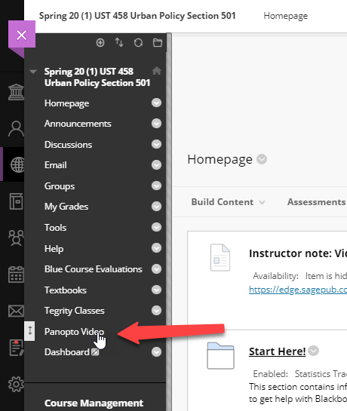
2. Once in the Panopto area, use the SQUARE symbol in the upper right portion of the screen to open Panopto in full screen mode.
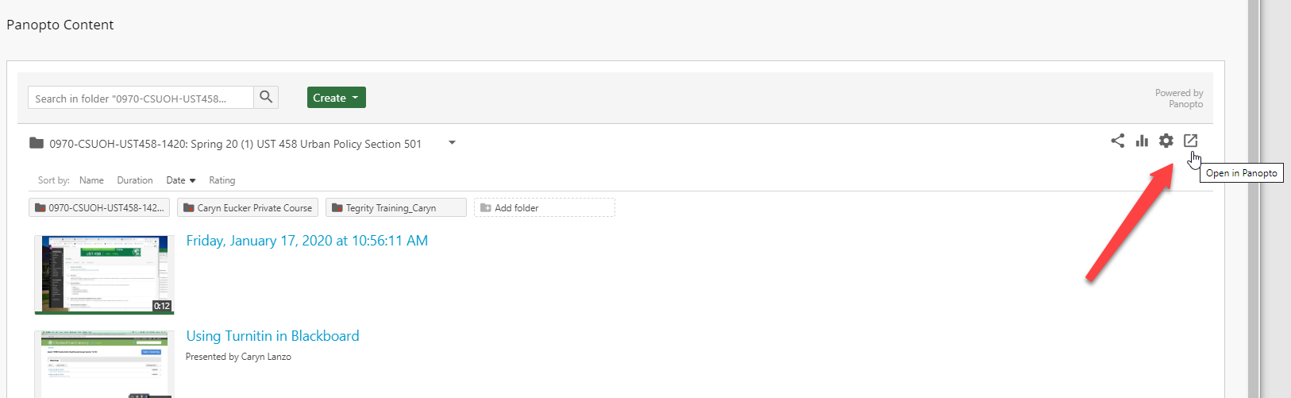

3. From the Panopto left navigation, choose “browse.” Navigate to Tegrity Migrations>YOUR ID folder.
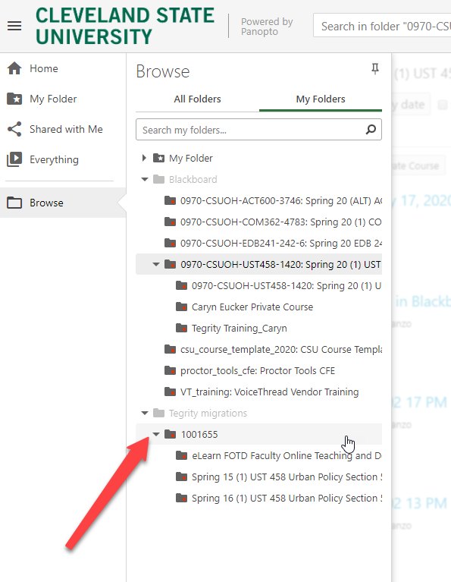

4. Choose (click on) a course folder that you want to move to a current course in Blackboard.
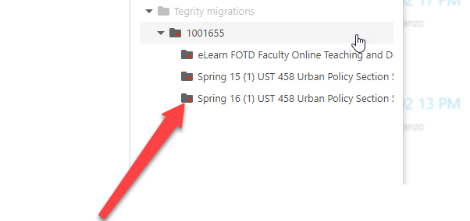

5. Use the select button to select all videos in the course.
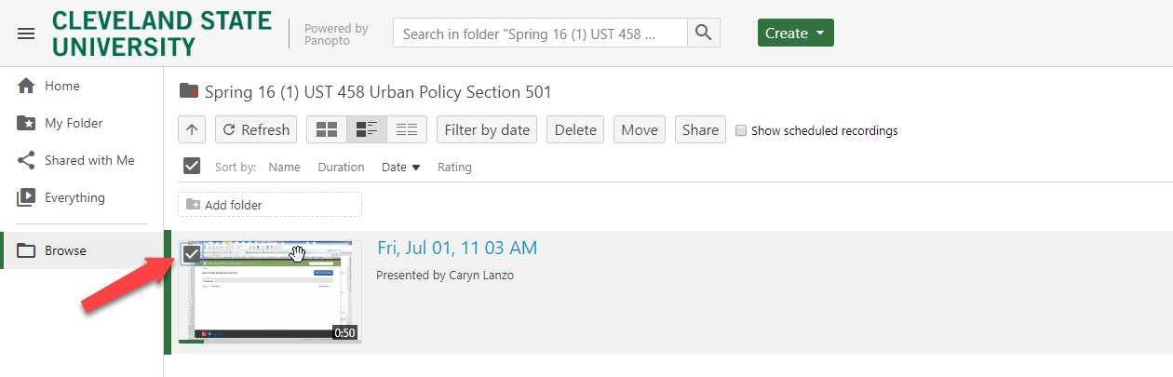
6. Click the move button in the horizontal menu above your video list.
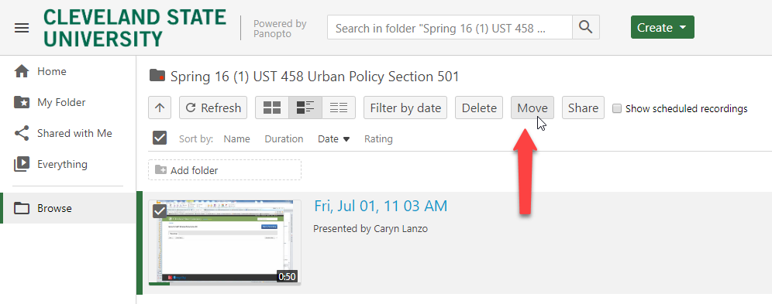
7. In the popup window, use the dropdown menu to select the course where you will move the videos. The course you select should be in your Blackboard folder.
