Instructions for replacing Tegrity links with Panopto links

1. Navigate to area in your course where you have Tegrity links.
2. Use the Create Menu to add a Panopto link: Build content>Panopto Video Embed. Select the video to embed in that space*
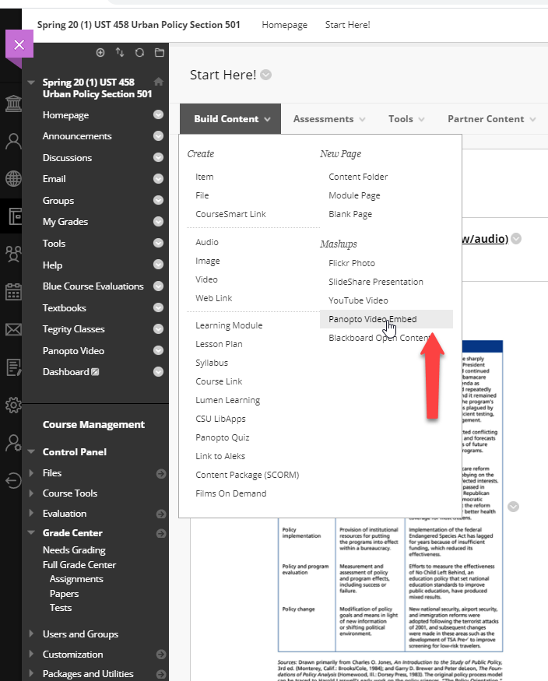

3. Using the submenu to the right of your Tegrity link, delete the Tegrity link.
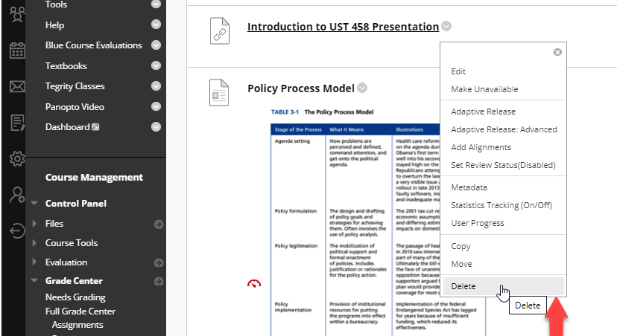
*Embed Panopto is a "mashup" tool in Blackboard, so you can embed Panopto video anywhere you have the content editor. Alternatively, you could copy the share link from the Panopto area and use that link anywhere in your course.

Content Editor in Blackboard:
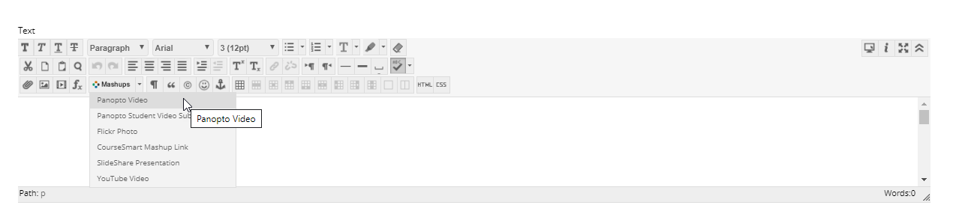

Share link in Panopto:
