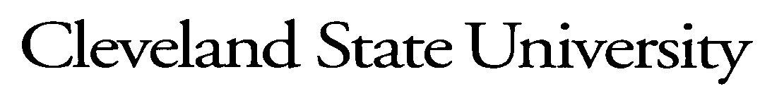

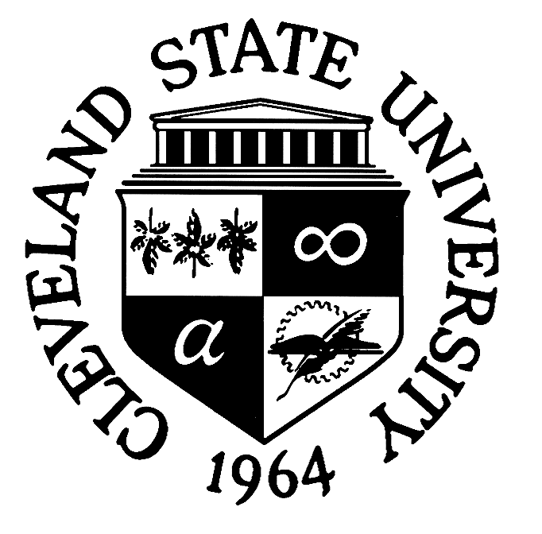

SEIU District 1199 & Cleveland State University
Staff Career Development Program
2020

Application and Program Guidelines

Deadline for Submission: November 20, 2020

SEIU District 1199 & Cleveland State University
2019 Staff Career Development Program

PROGRAM PURPOSE
SEIU District 1199, with support and funding from Cleveland State University, welcomes applications for funds to support the career development of SEIU bargaining unit employees, enhance their effectiveness, expand their contribution and commitment to their jobs, support student or employee engagement and retention, and clearly and directly benefit the University and its mission.

Collaborative awards: Colleagues and program areas are encouraged to partner to submit proposals that would provide opportunity for an expanded number of recipients. Such grant proposals may qualify for up to $2,500.00. For example: 2 advisors could partner and submit a joint proposal to bring a retention expert speaker to campus.

Individual awards: The maximum grant per individual award recipient is $750.00.

Individuals may apply for more than one grant, but will not receive funding for more than $750.00 unless it is a part of or is in addition to a collaborative proposal.

Awards will be determined by the Staff Career Development Awards Committee, comprised of union and management representatives.

TERMS
All current full and part-time non-probationary SEIU bargaining unit employees are eligible to apply. Proposals must be directly related to professional development. Items funded include but are not limited to: travel to attend or present at workshops or conferences; professional education; research support; in-service training.

Items excluded are: test fees, professional membership fees or dues, courses available at CSU covered by the Staff Development program, academic course textbooks, and software, hardware, and travel expenses for professional development opportunities available locally.

Please note members can apply for expenses already incurred starting as of July 1, 2020.

All funds must be expended by June 30, 2021.

APPLICATION PROCESS
To apply for a Career Development award, the SEIU bargaining unit employee(s) must complete the application form including:

1). Detail of the item(s) to be funded.

2). Description of the relationship of the proposal to the mission and goals of their department and/or their role at the University. A description as to how the proposal supports student or employee engagement and retention is required.

3). Supporting documentation of cost (airfare, hotel, conference fees, etc.) along with a statement of support from the applicant’s immediate supervisor. Collaborative awards should include at least 2 supporting statements from non-SEIU managerial personnel.

CRITERIA FOR RANKING
The following criteria will be used to rank the grant application proposals. Proposals will be funded from the highest ranked down until the allocated funds are committed.

Note: proposals will be disqualified if they do not clearly demonstrate a link to supporting student or employee engagement and retention.

1. Breadth of Benefit - Higher priority will be given to collaborative proposals that provide opportunity to benefit an expanded number of recipients. The next level priority will be given to individual requests that have a clear and demonstrable relationship to the employee’s job at CSU.

2. Availability of other funding sources - Favorable consideration will be given if matching support from the requestor’s department (or other funding support, such as an external grant) is provided.

3. Cost - Preference to lower cost proposals that enable approval of more proposals.

4. Date of Application - If other factors are relatively equal, preference will be given to applications received in order of submission.

APPLICATION DEADLINE: November 20, 2020

Applications must be received no later than November 20, 2020 to ensure timely review of proposals and awarding of funds. Applications must be submitted electronically. Please send via e-mail to Danielle Ruiz at d.ruiz@csuohio.edu.

Applicants will be notified of the committee’s decision by December 18, 2020.

APPLICATION FOR SEIU-CSU STAFF CAREER DEVELOPMENT PROGRAM GRANT

Name: _________________________________________________________________ (Please Print)
(Last) (First)

Title: _____________________________College:_______________ Department: _____________________

Campus Phone: ______________ Location: __________ Email address: _________________________

If submitting a collaborative proposal, provide information for all applicants (attach an additional sheet, if necessary).

Name: _________________________________________________________________ (Please Print)
(Last) (First)

Title: _____________________________College:_______________ Department: _____________________

Amount Proposed: $________________ Event Dates: ______________________________________

State your proposal and explain how it relates to your career development, the mission & goals of your department and Cleveland State University.

Brief Description of Proposal: (Attach additional detail and relevant supporting documentation.)

Specifically, how does it support student or employee engagement and retention?

Itemized Budget (estimated costs):

1. Total grant amount proposal: $___________

2. Total amount of departmental funding (if applicable): $___________

3. Additional sources of funding (if applicable): $___________
Identify source of additional funding: __________________

Total $ ___________
Cost projection of the total event: $_____________

_____________________________________________ ________________________
Employee Signature (primary requestor) Date

I understand that that this proposal may necessitate time off, and the employee and I have discussed the use of vacation, compensatory time or release time, as applicable. Final approval of the proposal is subject to the operational needs of the University.

_____________________________________________ _________________________
Supervisor signature Date

_____________________________________________ _________________________
Signature of non-SEIU managerial personnel, if applicable Date

Reimbursement of travel expense from grant awards is subject to university policy and procedure governing travel. The current travel policy uses the Federal Standard Meal Allowance (FSMA) to determine appropriate reimbursement rates for national and international travel. Applicants are encouraged to visit the Controller’s Office web page for information regarding Cleveland State University’s travel policy.

