How to Move Panopto Videos from Course to Course

When copying course content over, permissions to view Panopto videos are not updated. Meaning, students in your new course will not be able to see the videos that came from the original course (students will see a “Request Access” error”). To solve this issue, we recommend moving your videos from your original course into your new course through Panopto. The instructions below show you how to accomplish this task.

- Click on Panopto Video on the left hand navigation in the original course that contains the videos you wish to move.
- Click on the Open in Panopto icon [ ] to open the full version of Panopto.
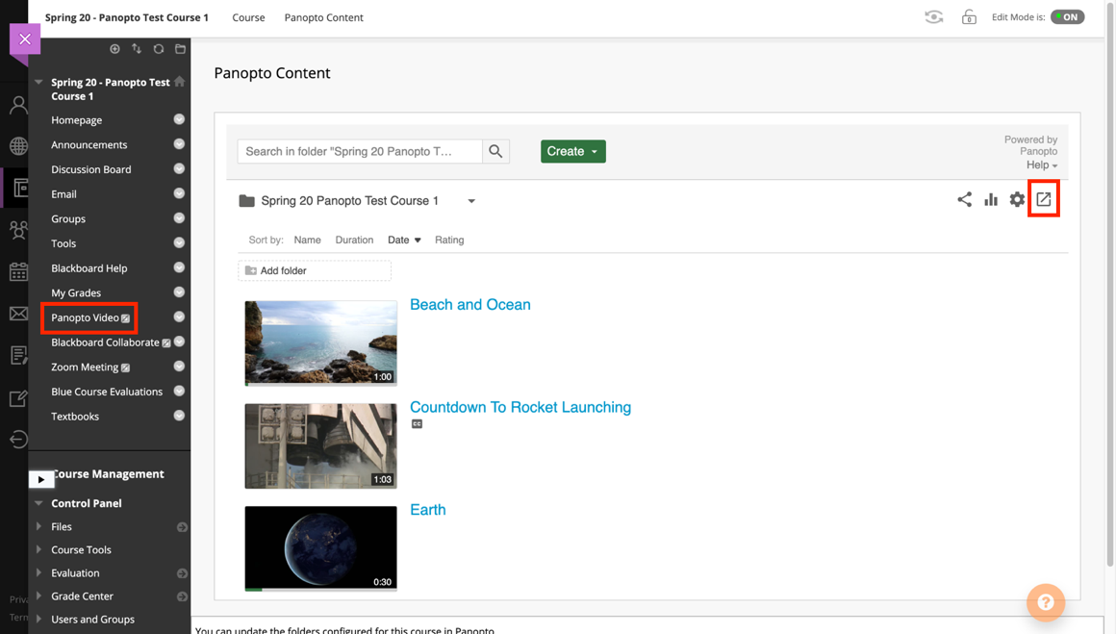
- Click the checkbox in the upper left-hand corner of every video you wish to move and click Move.

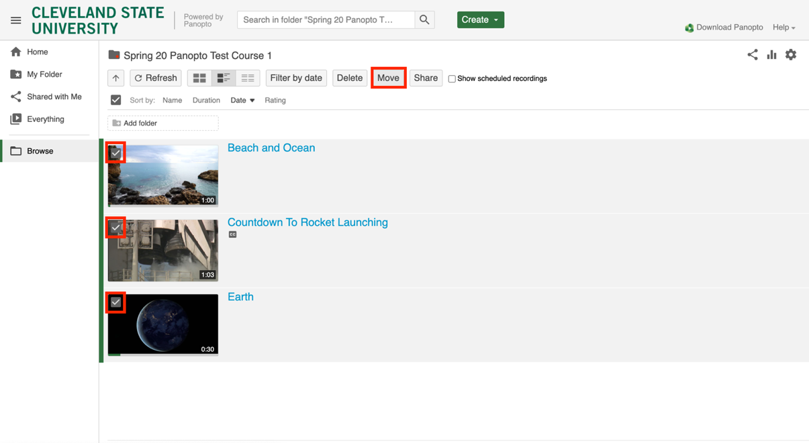

- Begin typing the name of your course. As you type, the search will begin auto-populating courses that you are enrolled in that have that name.

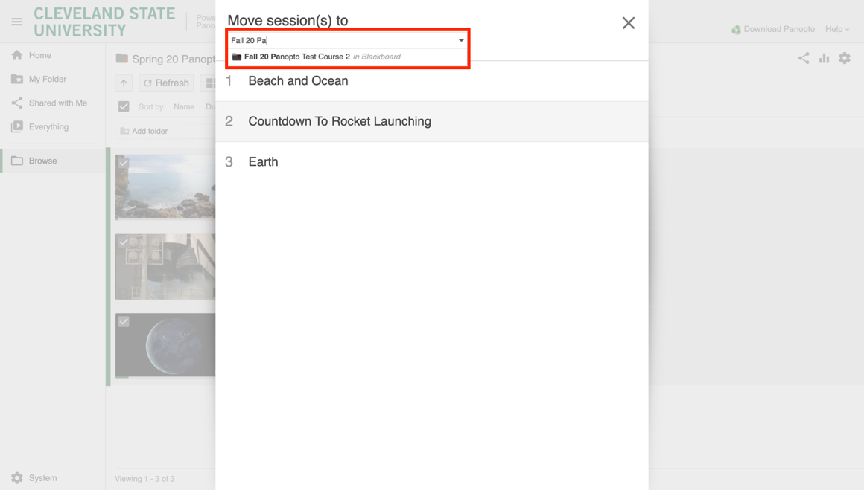

- Click Move.

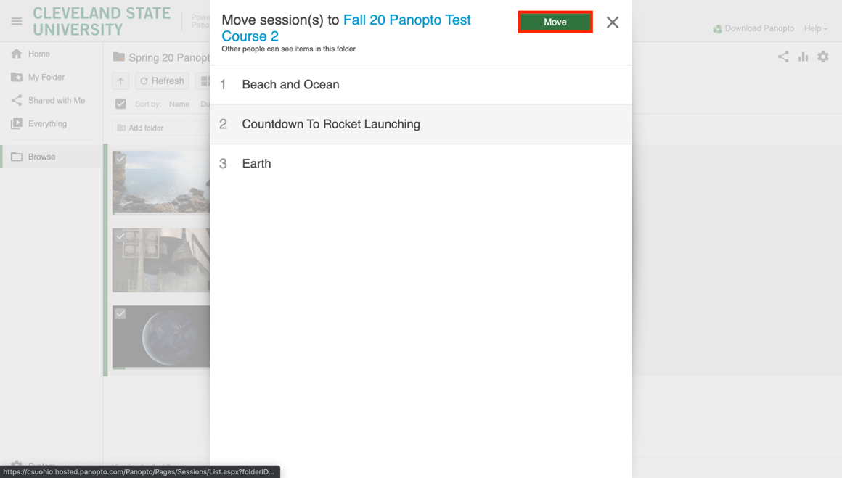
- A green checkmark next to each video indicates a successful move.

