Discussion Board Presentation
In this assignment please prepare a short video, only 1-2 minutes long, that describes a business article. The article should be related to the Discussion Board topic, but it does not need to be exactly what is discussed in the topic, it is more important for the information to be interesting. Please avoid specific “HR” or “Management” publications – instead, please use popular news sources, such as Bloomberg Businessweek, The Wall Street Journal, or the New York Times. Please use an article published within the last 12 months. In the video, three things are required:
- Facts from the article. Please include about 3-6 facts from the article that is important to the topic. You do not need to include all the facts from the article. It is up to you to choose the important information.
- Discussion / comment starters. Once you post the video to the Discussion Board, the rest of the class will discuss the information. Please include 2-3 questions to begin the conversation.
- Full citation of the article. You must include the title, author, source, and date of the article, in a proper MLA or APA citation. Without this credit your video would be considered plagiarizing.
You will need to sign-up for the discussion board you would like to submit to. The sign-up is available on the “Discussion Board Sign-up Wiki” in the Assignments tab of Blackboard. It is first come, first serve. If you have not signed up by the due date in blackboard (first week of class), then I will assign you to one of the discussion boards.
Your video does not need to have sound, in fact, I prefer information videos without sound. However, I would prefer the video is not a screen recording of a PowerPoint presentation. Instead, please check out some of the free software tools available online! These tools require you to sign-up for a free account. Here are a few I know about, but you are welcome to use anything.
- Adobe Spark – This one is my favorite. Very easy to use, set up similar to powerpoint, and you download the video onto your computer. https://spark.adobe.com/sp
- Powtoon – Pretty easy to use, I suggest starting with a template. You cannot download the video, you must upload to YouTube. It is still easy to upload to Blackboard though. https://www.powtoon.com/my-powtoons/?#/
- Biteable – This one seemed very slow so I did not like it as much. You would need to upload to You Tube and some of the rendering took 15 minutes. https://biteable.com/
- Moovly – This one was my least favorite. It required a lot more work and was difficult to use a template. However, perhaps if you have previous video experience then you may like it. https://www.moovly.com/
As an added bonus - the best video of the week will earn 5 points extra credit!!
Finally, you will need to upload to the Discussion Board. This is easier than it sounds. I will show you how I uploaded my Adobe Spark first, then how to upload from YouTube. (See next page)
- Enter the discussion board and click “Create Thread” (circled below in red): 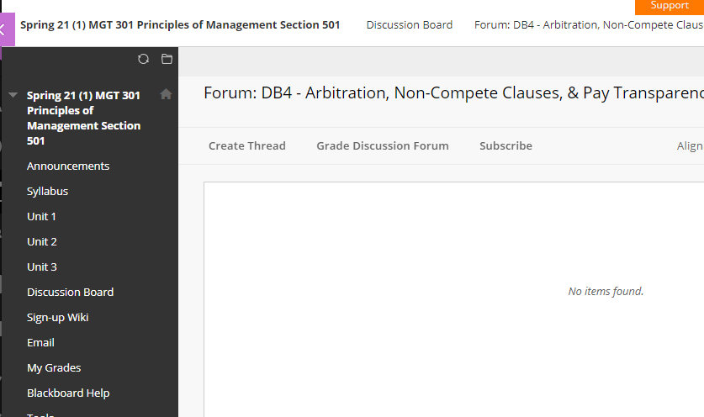
- Enter a subject (your position – see instructions) and then click the insert button (circled in red below): 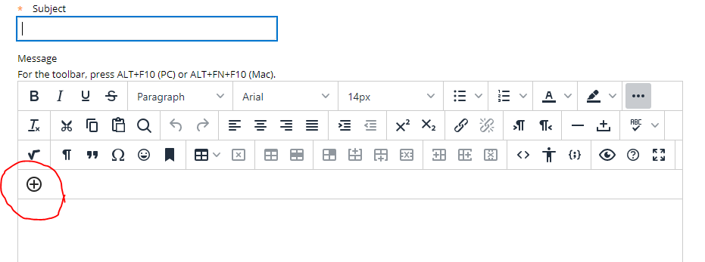

- If you are uploading from your computer, then select “Insert Local Files”, circled in red below. If you are uploading from YouTube, then skip down to step 6.
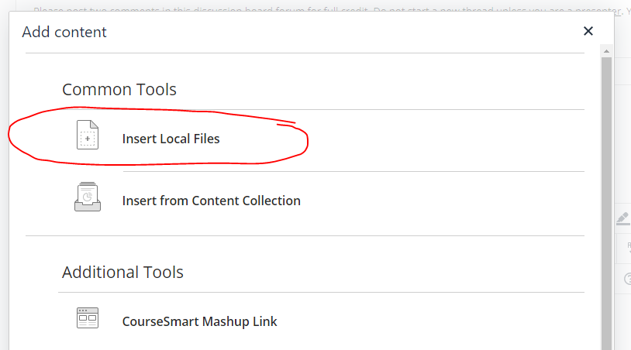

- Select the file from your computer and the file will begin uploading (the file is uploading so It might take a minute). You will see the video preview below. You may change the dimensions if you like (though not really necessary), but make sure the “Constrain Proportions” is checked. Then click “Insert”.

- You will return to the Create Thread page. You may see the video, or you may see a yellow box where the video will be, either way is fine. Click “Submit” to post to the Discussion Board.

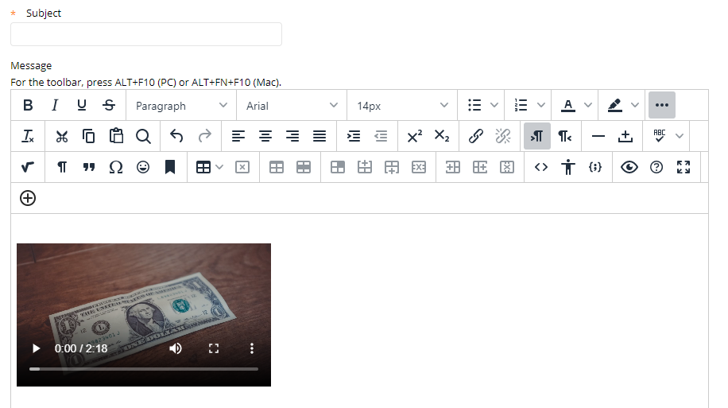

- If you are posting something from You Tube complete steps 1-3 above. Once you click the insert media button (plus sign), scroll down in the pop-up box and select “YouTube Video” (circled in blue below):
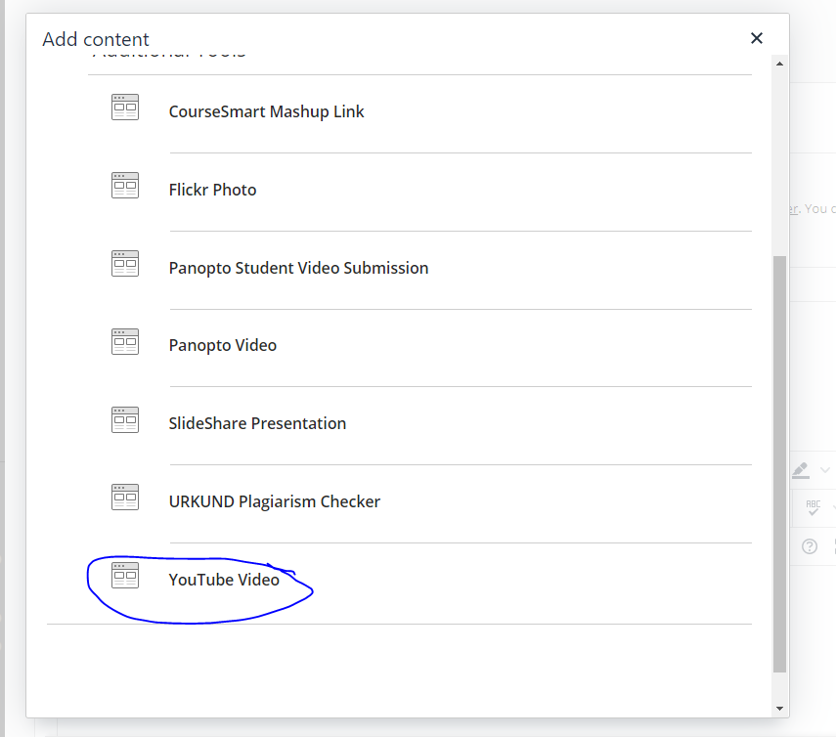
- Search for you video. If you don’t find it right away, then you can filter the results by when the video was uploaded. Click “Select” when you found your video:
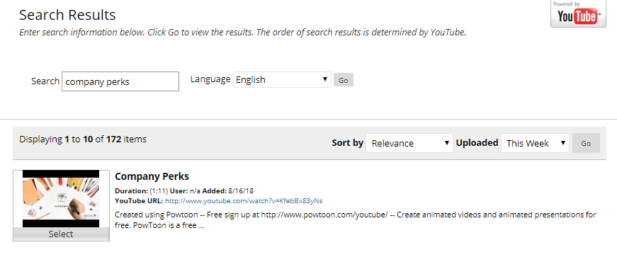
Click “Submit” on the next screen, where you will see other options and details. You will be returned to the Create Thread page (see below). Click “Submit” to post.

