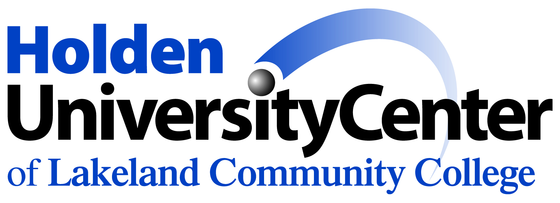
Bachelor of Arts in Psychology
Partnership between Lakeland Community College (LCC) and Cleveland State University

Foreign Language
2 years of the same foreign language in high school, or 2 semesters of the same foreign language in college are required by Cleveland State University. Waived for those who graduated high school 1987 or earlier.

Completion of the Ohio Transfer Module at LCC completes a subset of CSU’s General Education Requirements. A student who completes the transfer module from LCC has only to complete Cleveland State’s Writing Across the Curriculum (WAC) and Capstone requirements in order to complete Cleveland State’s General Education requirements in their entirety. Students must meet with a Lakeland Community College advisor to determine whether they will be completing LCC’s transfer module. The CSU advisor will not make this determination.
https://www.csuohio.edu/transfer-module/transfer-module
A student who does not complete the Transfer Module at LCC will need to complete CSU’s General Education Requirements and should follow the most current LCC to CSU transfer guide.
https://www.csuohio.edu/transfer-guides/lakelandcc-science-health-professions
General Education Courses needed for the PSY Major-
- PSY 101 (CSU) or PSYC 1500 (LCC) – Introduction to Psychology
- PSY 217 (CSU)-Behavioral Science Stats: Descriptive or STA 147 (CSU) or MATH 1330 or MATH 1550 (LCC) is required for the Psychology major. LCC students are encouraged to plan accordingly because MATH 1330/1550 does have other pre-requisites.
Additional CSU BA Psychology Requirements:
- A minimum of 120 total credit hours (including all eligible transfer credits from LCC* and all credit earned at CSU).
- A minimum of 42 total credit hours of Junior/Senior (CSU 300/400) level courses (referred to as the “upper division requirement”). LCC’s PSYC 2300, PSYC 2700, PSYC 2800 will transfer as 300/400 level CSU credits.
- Cleveland State University Residence Requirements: A total of 30 credit hours of study must be taken from Cleveland State.* These courses can be taken online, CSU main campus or through CSU courses offered at the Holden Center.
- 24 upper division credit hours must be taken through Cleveland State (300/400 level)
- A minimum of 18 credit hours toward PSY major must be taken through Cleveland State and 12 must be 300/400 level
*NOTE: Partnership students are advised to take no more than 90 credit hours of transfer credit. (Transfer credit will only be awarded for credits which are not considered remedial in nature.) Plan accordingly for pre-requisites.

- Partnership students should meet with the CSU academic advisor at least once per semester. Advising is currently available on a remote basis.
- CSU is committed to offering 2-3 appropriate courses each semester at the Holden Center (including through IVDL) with enrollment preference for partnership students. Other PSY online courses are offered to the general CSU student body each semester, but do fill quickly. Be aware that partnership students who are unable to travel downtown, have scheduling limitations or have not planned pre-requisites accordingly may have to delay completion of the PSY degree.

CSU Requirements – Psychology Major  (A grade of C- or higher is required in ALL Psychology courses to count toward the major) |  | Courses to take at Lakeland that fulfill the CSU-LCC PSY partnership requirements
 | Introductory Psychology Course  PSY 101 Introduction to Psychology (3) | PSYC 1500 Introduction to Psychology (3)
 | PSY 200 Majors Guide-PSY (1) | No Equivalency
 | Psychology Statistics Courses  PSY 217 Behavioral Science Stats: Descriptive (3) or STA 147 Statistical Concept with Apps (3) may be substituted  AND PSY 317 Behavioral Science Stats: Inference (3) or STA 347 Applied Statistics (3) may be substituted | MATH 1330 OR MATH 1550 (see Math/Quantitative Literacy requirements)  No Equivalency  Must be completed through CSU
 | Psychology Research Course 1  PSY 312 Research Methods (3) | No Equivalency  Must be completed through CSU
 | Psychology Research Course 2  PSY 415 Evaluating Psychological Research (3) OR  PSY 412 Psychology Laboratory (3)  (Either course can apply toward the Writing Across the Curriculum in major) | No Equivalency  Must be completed through CSU
 | Psychological Health Core  Choose 1 course from this list offered through CSU:  PSY 345 Abnormal Psychology (3)  PSY 353 Health Psychology (3) | The appropriate CSU course OR  PSYC 2700 Abnormal Psychology (3)
 | Social /Personality Core  Choose 1 course from this list offered through CSU:  PSY 339 Social Psychology (3)  PSY 342 Psychology of Personality (3) | The appropriate CSU courses OR  PSYC 2800 Social Psychology (3)  PSYC 2300 Personality Theory (3)
 | Perception and Cognition Core  Choose 1 course from this list offered through CSU:  PSY 368 Perceptual Processes (3)  PSY 372 Memory and Cognition (3) | No Equivalency  Must be completed through CSU
 | Neuroscience Core  Choose 1 course from this list offered through CSU:  PSY 482 Biological Basis of Behavior (3)  PSY 487 Brain and Cognition (3) | No Equivalency  Must be completed through CSU
 | Additional Core Course  Psychology students must complete a 5th Core course for a total of 15 credits of Core courses | The second of PSYC 2300 and PSYC 2800 can be taken through LCC  OR  Students can take additional Core classes through CSU
 | Psychology Electives  A minimum of 12 credit hours in Psychology electives are required. Students must earn an overall total of 42 credit hours in Psychology.  Electives can be selected from:  - Lakeland Psychology courses  - CSU Psychology courses offered at the Holden Center  - CSU Psychology courses offered online or at the CSU campus  In addition, any course listed above and not used to satisfy the Core area requirement may be used as a PSY elective. | LCC Psychology electives/CSU Equivalents  PSYC 2100 Lifespan Development for Nursing (3)  (equivalent to PSY 223 Life Span Development at CSU)  PSYC 2400 Child Psychology (3)  (equivalent to PSY 220 Child Development at CSU)  PSYC 2500 Adolescent Psychology (3)  (equivalent to PSY 221 Adolescent Psychology at CSU)  PSYC 1700 Psychology of Gender (3)  (equivalent to PSY 255 Psychology of Women at CSU)
 | Writing Across the Curriculum  A grade of C or higher is required in WAC courses  Only 2 courses required If transferring 60-89 credit hours  Only 1 course required (WAC in major) if transferring 90+ credit hours | Only CSU courses may satisfy the WAC requirement  May be taken online or at a CSU campus (including Holden Center)  At least one WAC course must be taken within the Psychology major  (PSY 412 or PSY 415 will satisfy the WAC in major requirement)
 | Exit Evaluation  PSY 499 Exit Evaluation (0) | No Equivalency  Must be completed through CSU

Partnership Hints
- When applying to CSU you must complete the Supplement Application for Partnership Admission form
- CSU courses are available at Holden University Center, web based (online) or CSU campus
- Financial aid can only be used at one institution at a time
- Associate degree requirements are not listed on this guide. Consult with an LCC Counselor to verify requirements for the Associate degree

*To schedule an appointment with a CSU Academic Advisor once admitted, please call 216-687-9321
Revised September 2021

