Cleveland State University
Journal Entry Instructions

Purpose of Journal Entries
- To move a transaction - transfer a charge or revenue from one cost center to another. A PDF copy of the page of the transaction register showing the charge must be included as back-up.

- Reclass - to correct an account code (first four-digits) for an item that has been categorized improperly. A PDF copy of the page of the transaction register showing the charge must be included as back-up.

- Billing - to charge another CSU department for goods or services provided.

- Transfer funds between Fund codes – these journals utilize either account code 0999, or account code 0995 for BOTH sides of the transfer. All entries to 0999 must always balance to zero -0-. All entries to 0995 must always balance to zero -0-. Note: transferring funds within the same Fund code is done via Budget Transfer, not Journal Entry.
How to prepare a Journal Entry
- Open the journal entry form located on the Controller’s website. At the top, enter Source Code if applicable
- Enter the appropriate Chartfields in the spaces provided. The Chartfield numbers are text formatted and have a certain number of characters (see below).
NOTE: Only enter data in the chartfields applicable to your journal entry. Leave fields blank if no information is needed for a chartfield.
- Account – 4 characters
- Fund - 4 characters
- Department – 4 characters
- Program – 2 characters
- Class – maximum 5 characters
- Project – maximum 9 characters
- Enter the budget year - 4 digits (text format)
- Enter the amount for each line in the Amount column. The amount is the only field that must be in number format, with 2 decimals and no commas.
- Line Reference – maximum 10 characters
- Line Description – maximum 30 characters; description should be brief, but thorough
- Journal Header Description – maximum 30 characters; description should be brief, but thorough
NOTE: Due to system constraints, commas are not allowed in any of the fields or “xxxx’s” in empty fields. There should not be any blank rows between entries. If more rows are needed, copy and insert rows.
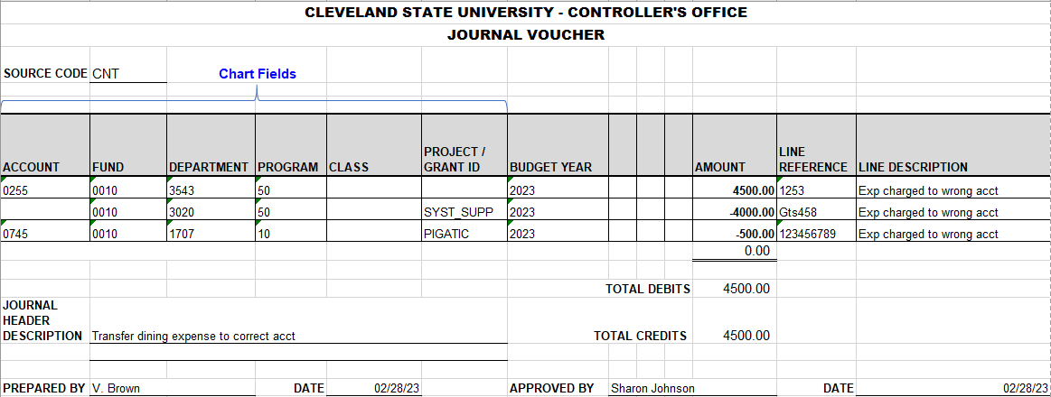

Once all entries have been entered onto the journal voucher, the total amount column should be 0.00 (zero) and the total debits and credits should equal (see circled above).
CLEVELAND STATE UNIVERSITY
Submitting Journal Entry Vouchers to Controller’s Office

The Controller’s Office is responsible for assuring the financial integrity of the University. The purpose of this document is to formalize the University procedures regarding general ledger entries.
Journal entries can be initiated as frequently as necessary by University Department’s or the Controller’s Office. They should be submitted electronically (via email) to the Controller’s Office general mailbox at controller@csuohio.edu using the standard approved form below.
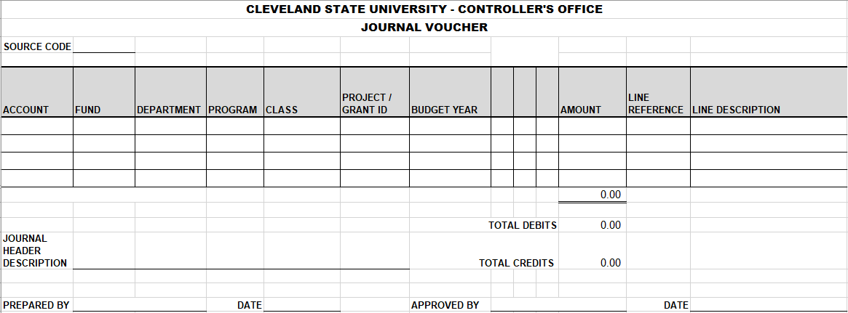

Journal Entry Format
- All journal entries must have supporting documentation attached. If the journal entry is correcting an error, the documentation must include a description identifying the nature of the error.
- All journal entries (including monthly departmental charges) must include the appropriate chartfields; account, fund, department, program, class and project (xxxx-xxxx-xxxx-xx +/- class/project code).
- The line reference, if used, can only have a maximum of 10 characters.
- The line description and journal header description should have a brief, but thorough description. These fields have a maximum of 30 characters.
NOTE: All the above fields are text formatted. The amount is the only field that must be in number format, with 2 decimals and no commas. Due to system constraints, commas are not allowed in any of the fields or “xxxx’s” in empty fields. There should not be any blank rows between entries. If more rows are needed, copy and insert rows.

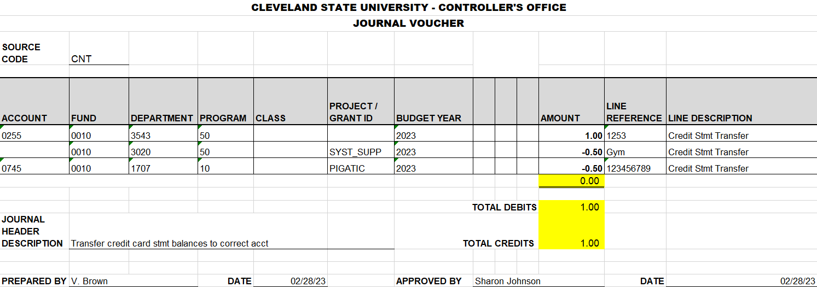

- Once all the information is on the journal voucher, the total should be zero and the debits and credits should equal (see highlighted area above). Submit to Controller’s mailbox along with the backup for the journal entry.
- Please DO NOT reformat the template. The template is set up for PeopleSoft to read it. Any change will result in an error and delay posting the journal entry.
Errors
- Any journal entry that cannot post in PeopleSoft due to an error, will be returned stating the error(s). The entire journal voucher will be returned. Partial entries WILL NOT be posted. Please return the corrected journal voucher to the Controller’s staff who sent it to you. Submit the revised journal voucher as soon as possible. If it cannot be returned by the end of the month or the chargeback due date, resend to the Controller’s email to be posted the next month.
Approvals
- Any grant lines that need to be approved by the Sponsored Programs Department (SPRS), must be approved before submitting to the Controller’s mailbox.
Monthly checklists are utilized to ensure that all normal recurring journal entries and departmental billings have been received and posted to the general ledger. However, it is the responsibility of the department and/or University Fiscal Officers to send their journal entries to the Controller’s Office before the posted due dates.
The general ledger is balanced and closed every month. As part of the monthly close, the general ledger is reviewed for accuracy, which includes but is not limited to unposted entries, entries with missing department codes, program codes, etc. A posting report is prepared at the end of each month prior to closing. The posting report is compared to what was posted via a general ledger report to ensure all items posted correctly.

