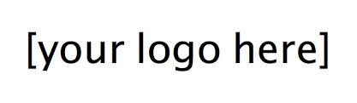
About us:

POSITION/JOB TITLE:

POSITION TYPE:

POSITION DESCRIPTION:

POSITION ACCOUNTABILITIES:

ADDITIONAL DOCUMENTS
REQUIRED TO APPLY:

POSTING DATES:

SALARY:

DAYS/TIMES NEEDED:

QUALIFICATIONS:

DESIRED MAJORS:

WORK AUTHORIZATION:

DESIRE CLASS LEVEL:

DESIRE DEGREE LEVEL:

LEARNING OBJECTIVES:

FOR OFFICE USE ONLY
CONTACT:

EMAIL TO SEND

APPLICATION DOCUMENTS:

DEFAULT EMAIL FOR CAREER SERVICES COMMUNICATION AND RESUMES:

