How to get roster information from Blackboard
Instructors can download their gradebook to get a list of all students enrolled in their course. The gradebook can be downloaded in a format compatible with Microsoft Excel. Gradebook columns automatically included include first name, last name and “username,” which is the CSU ID.
Instructors can access the gradebook in their Blackboard course, regardless of whether or not they are using the Blackboard course shell.
Faculty can login to Blackboard and choose “courses” from the global navigation. Navigate to the course desired and click to enter.
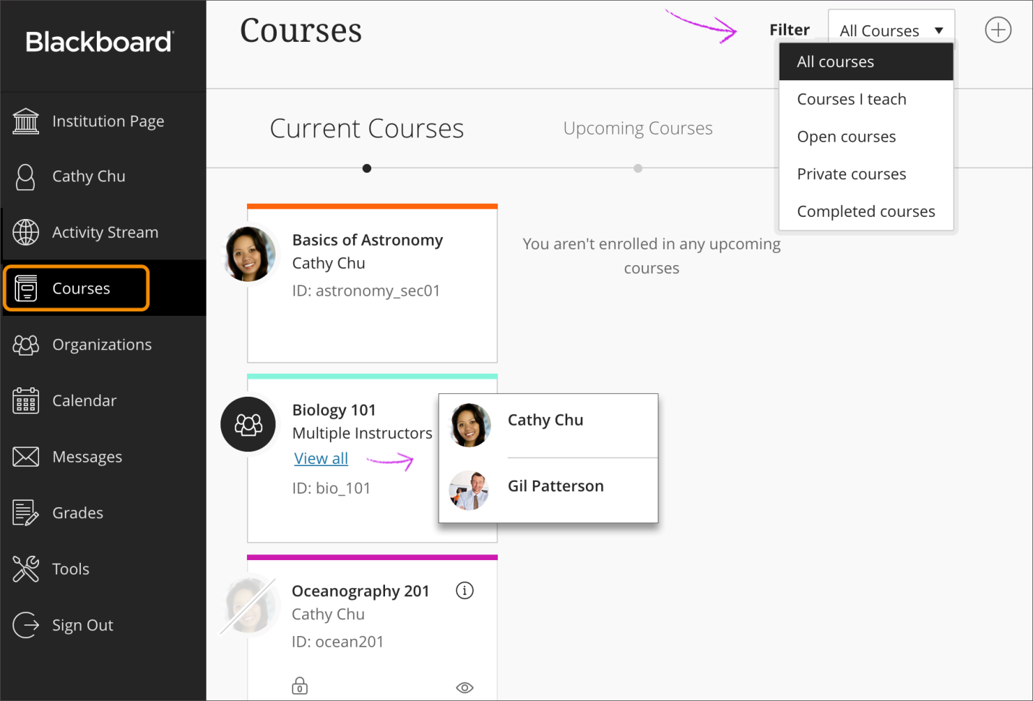
One in the course, choose Grade Center>Full Grade Center from the left navigation. Then choose “work offline” 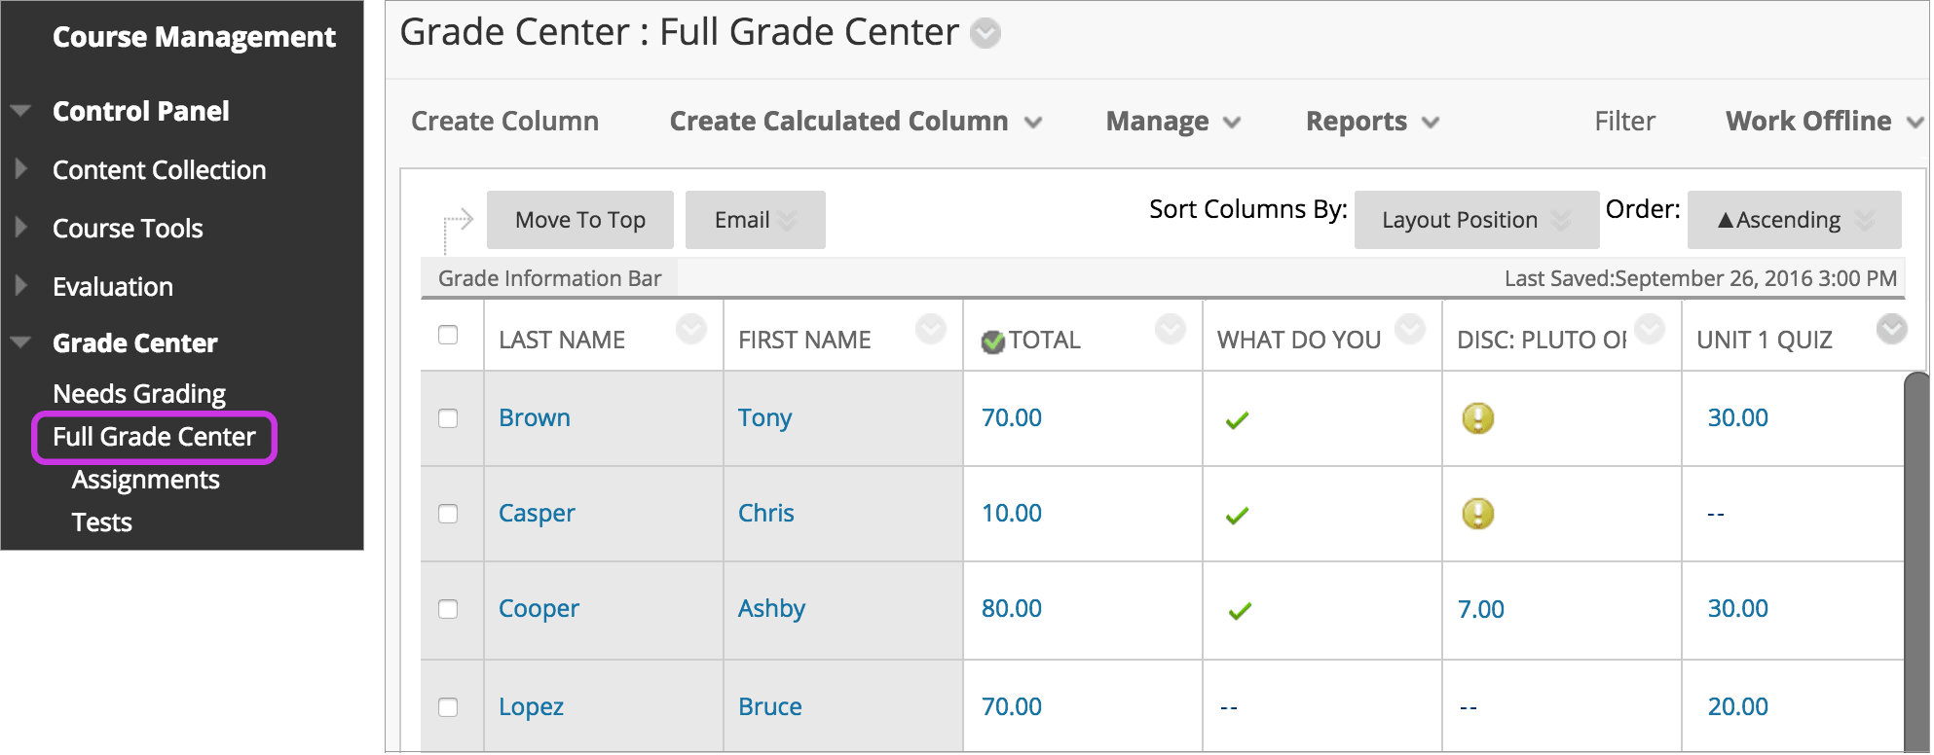
Download grades from the Grade Center
You can download full or partial data from the Grade Center.
- Access the Work Offline menu and select Download.
- Select the data to download as described in this table.
Option | Description
Full Grade Center | Contains all columns and associated data. Comments won't be included, and you can't add them offline.
Selected Grading Period | From the menu, select a grading period. You must create grading periods before you can choose any.
Selected Column | From the menu, select one column and its data. Select the check box to Include comments for this Column. Comments will download from the Quick Comment feature or Manual Override tab. You can edit included comment text offline.
User information | Columns containing student data such as username are included.
- Select the file delimiter, Comma or Tab.
- Select whether or not to Include Hidden Information in the downloaded data. Hidden information includes columns and students you hid from the view in the downloaded file.
- Select the location for the download. Browse to select a folder in the Content Collection if you have access to it.
- Select Submit.
- On the next Download Grades page, select Download and save the file.

Need help? Contact the Center for eLearning, 216.687.3960 or elearning@csuohio.edu

