Sending Grades from Blackboard to CampusNet

It is now possible to send final grades from Blackboard into CampusNet. Though the grades can be sent from Blackboard, once imported into CampusNet, you will still have the ability to override the grades there. You may send grades from Blackboard into CampusNet as many times as you’d like prior to submitting grades in CampusNet.

The steps to send grades from Blackboard to CampusNet require you to:
- Check the default grading schema in Blackboard
- Set up your final (external) grade column in Blackboard
- Send grades from Blackboard
- Import grades from CampusNet

The following instructions will ensure that the proper setup in Full Grade Center has been completed to ensure the successful transfer into CampusNet.

Check the Default Grading Schema in Blackboard

- Ensure the Grade Schema is correct per your syllabus. The default grading schema is based on CSU’s approved schema. It you have a different schema or would like to look at the one currently set, go to Full Grade Center -> Manage -> Grading Schemas.

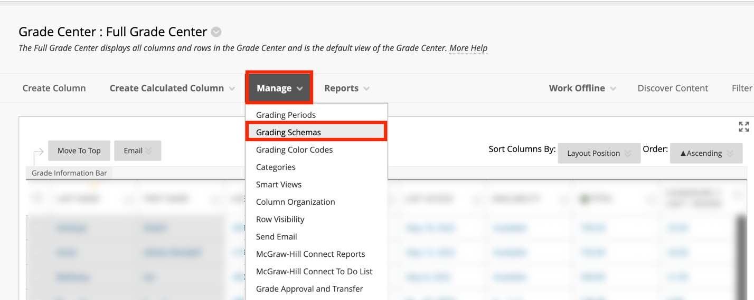

- Click on the chevron next to the default Letter schema and click Edit.

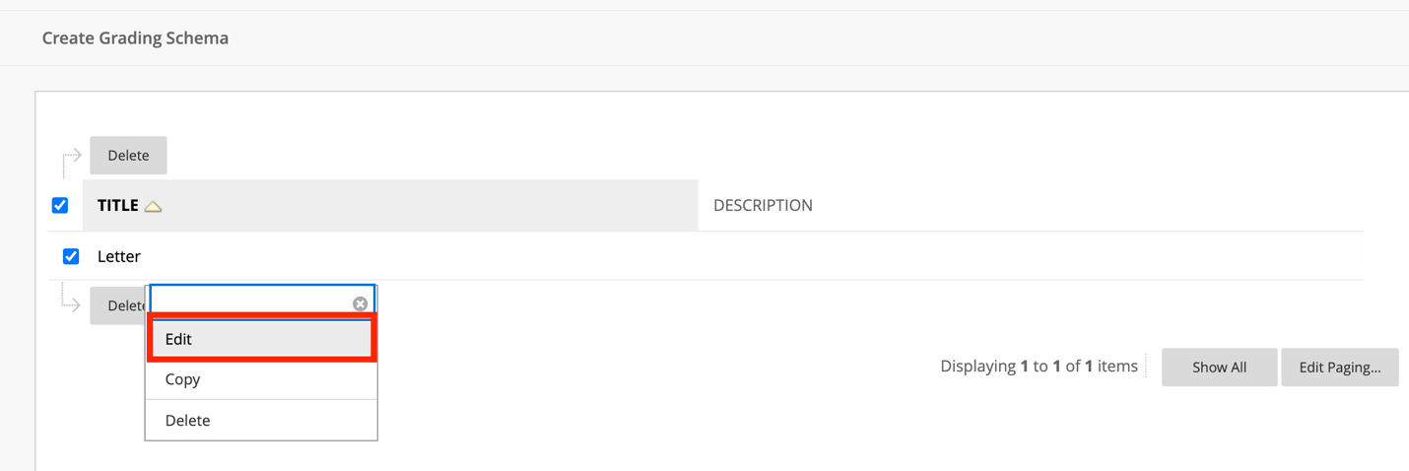

- Ensure the Grading Schema matches that provided in your syllabus. Once complete, click Submit. If you need assistance adjusting this area, please see Blackboard's grading schemas help page, or email the Center for eLearning at elearning@csuohio.edu.

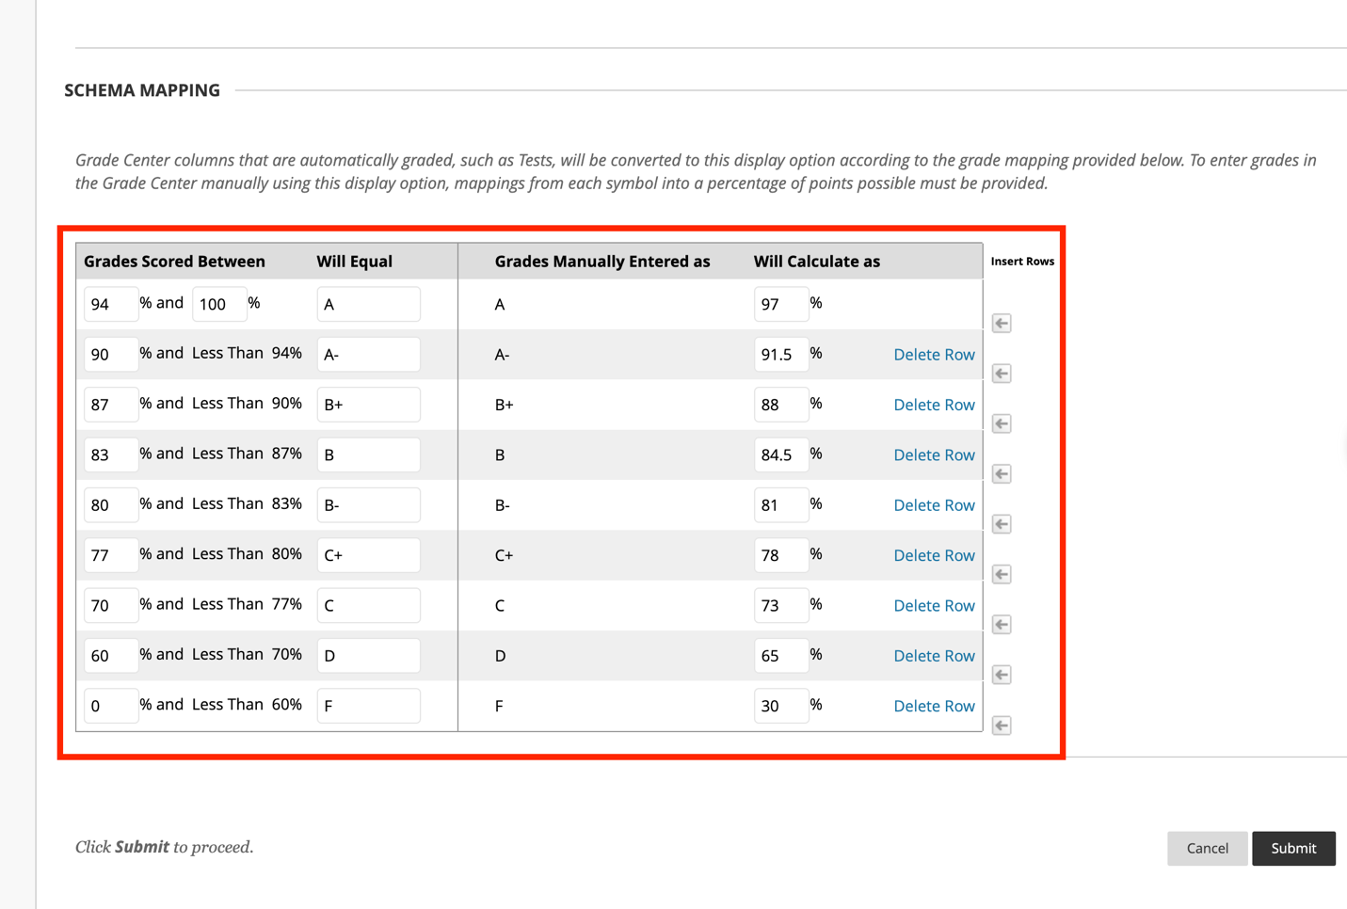

- For Graduate level courses that do not offer C+ or D as a grade, you must delete these specific rows.

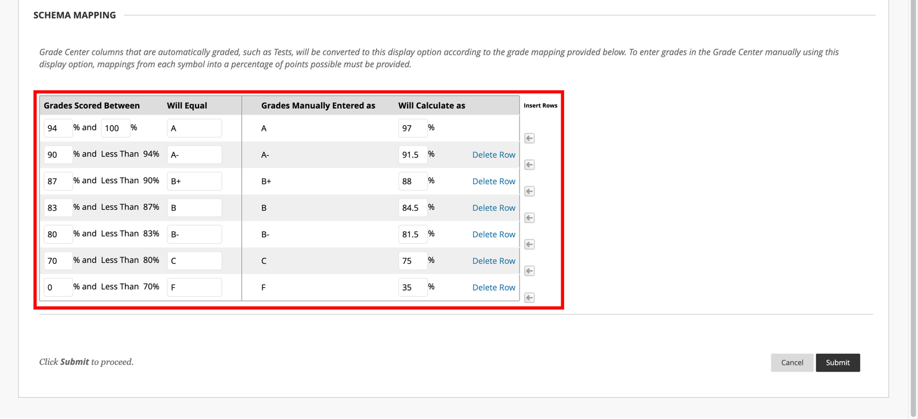

- Important Note: If the C+ or D rows are not removed from the grading schema and a graduate student earns that grade, Blackboard will send it, but you will receive an error in CampusNet notifying you that a C+/D is not allowed. Only that grade will not import. All other grades will successfully import.

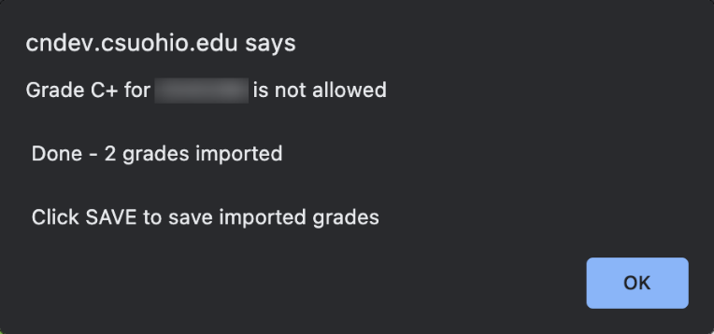

Set up your Final (External) Grade Column in Blackboard

The column that is sent to CampusNet is known in Blackboard as the External Grade column and is indicated by a green checkmark to the left of the column name. By default, the Total column in Blackboard is predefined as the External Grade. However, it can be changed to whatever column is going to be sent to CampusNet

In order to successfully send grades to CampusNet, the following must be done:
- The final grade column must be set to External Grade (if different than the Total column)
- The Primary Display of that column must be set to a Letter grade (determined by the Grading Schema mentioned in the section above).

The following instructions outline how to complete each step.

- Ensure the correct final grade column is set to the External Grade. This column is indicated by the green checkmark to the left of the column name.

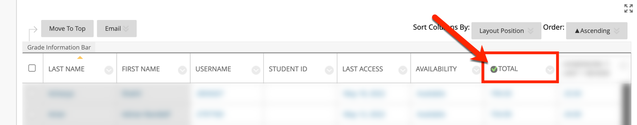

  - If you need to assign another column as the External Grade, click on the chevron to the left of the column title and click Set as External Grade. A green checkmark will now appear to the left of the column name.

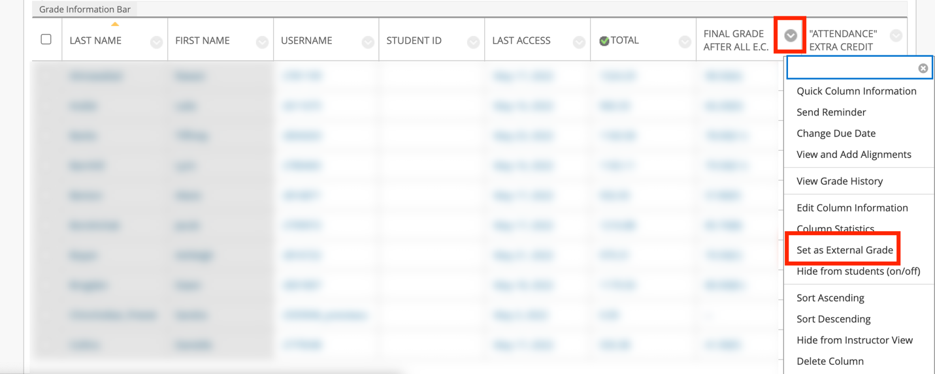

- The External Grade column must now be set to display a letter, as that is what CampusNet is expecting. To adjust the display for the External Grade column, click on the chevron of the External Grade column and select Edit Column Information.

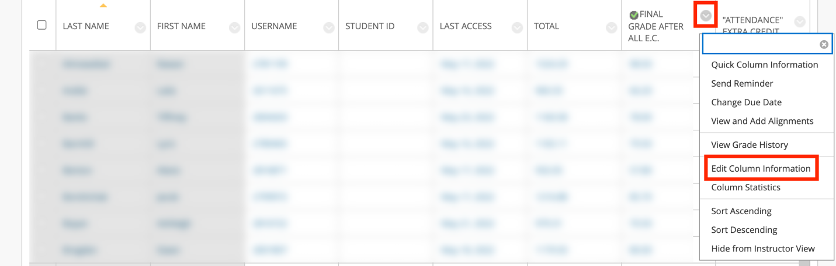

- The Primary Display field needs to be set to Letter. Click Submit. (Note: you may also set a Secondary Display in this area if you want to show students their point value or overall percentage. Adding a Secondary Display will not impact what is sent to CampusNet.)

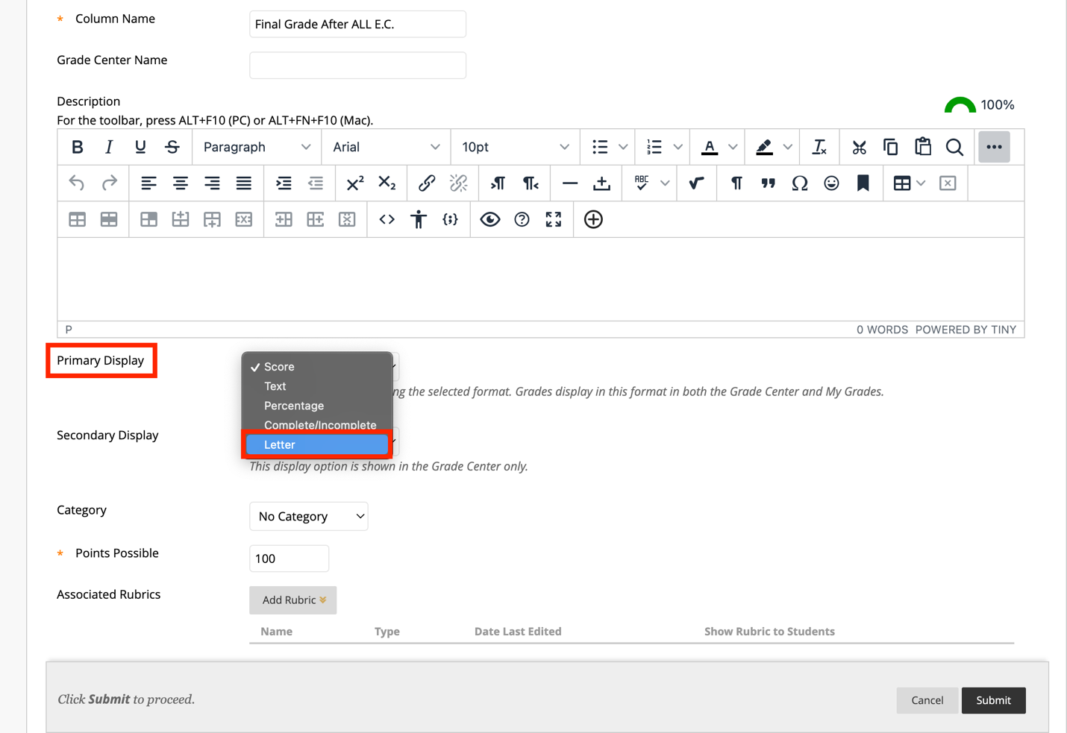

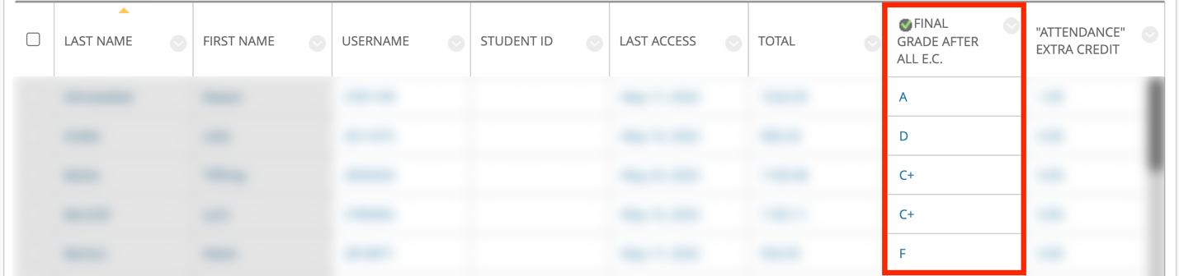

Send Grades from Blackboard

- With the setup complete, grades are now ready to be sent to CampusNet. To initiate the process, navigate to Manage -> Grade Approval and Transfer.

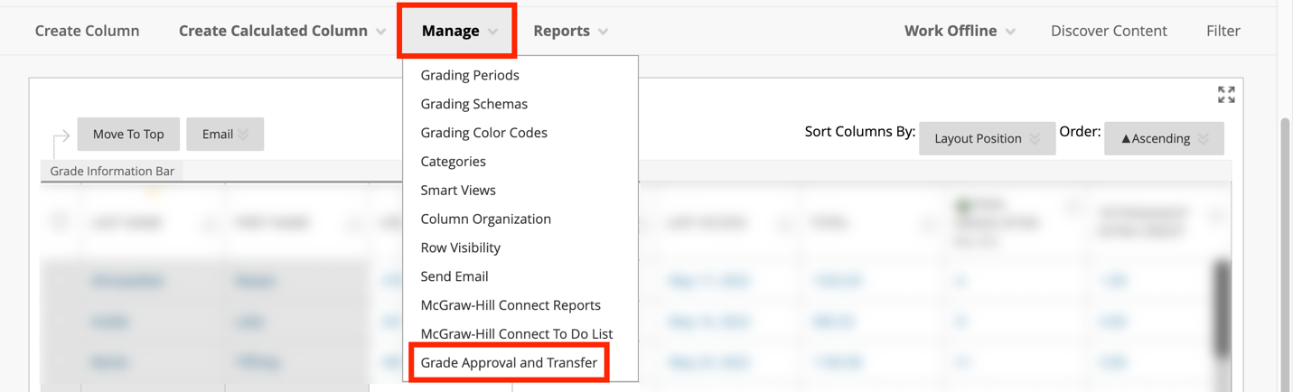

- Scroll until you see the course and the buttons at the bottom. Check the box to the left of your Course ID and click the Extract Grades button.

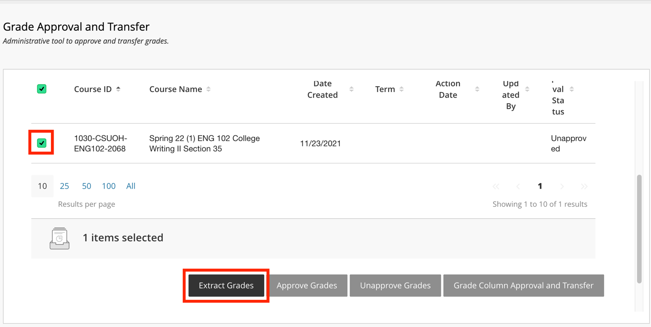

- You will be asked to confirm the extraction. Click OK. Once extracted, grades are sent to CampusNet.
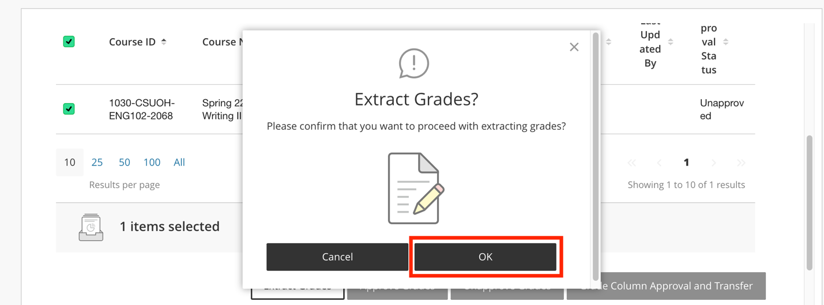

- You will receive a confirmation message in Blackboard once the extraction process is complete.

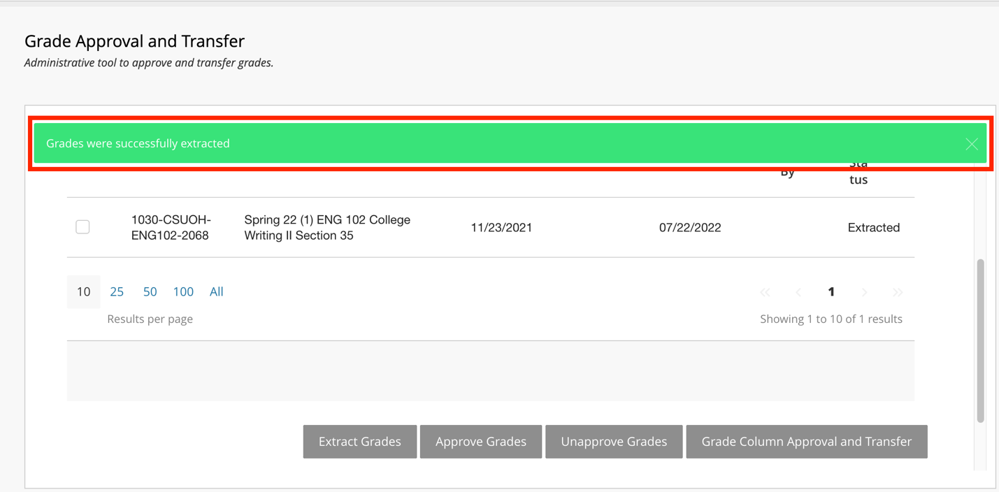

Import Blackboard Grades in CampusNet

Now that the grades have been successfully extracted in Blackboard, you can now go into CampusNet to import them.

- Log into CampusNet with your CSU ID and password.

- Click on the Instructor tab.

- Click on the dropdown and select the semester you are entering grades for and click Continue.

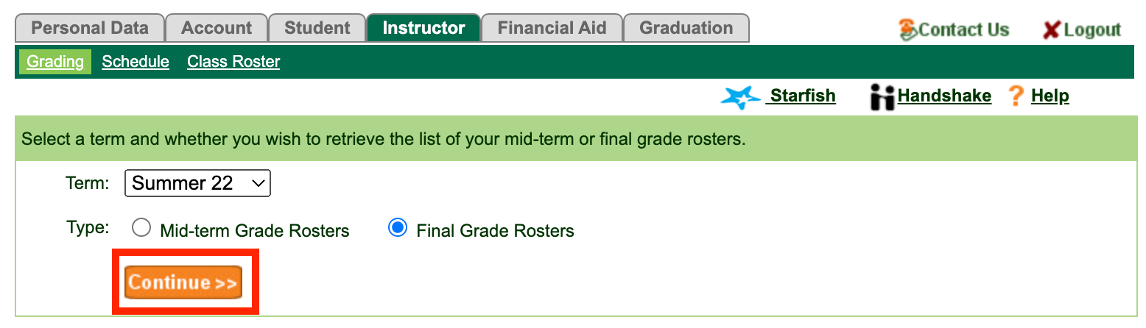

- Click the Open button to the left of the course you would like to import the grades for.

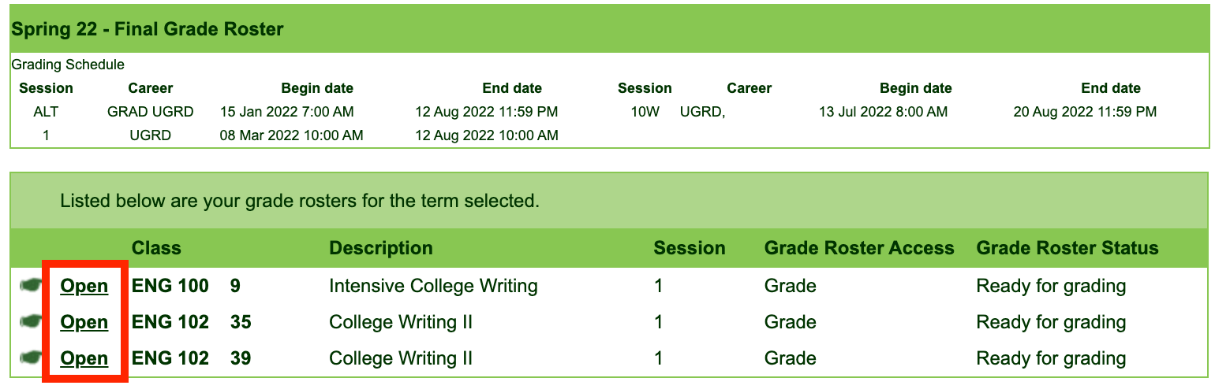

- You will see a new button labeled Import grades from Blackboard. Click this button.

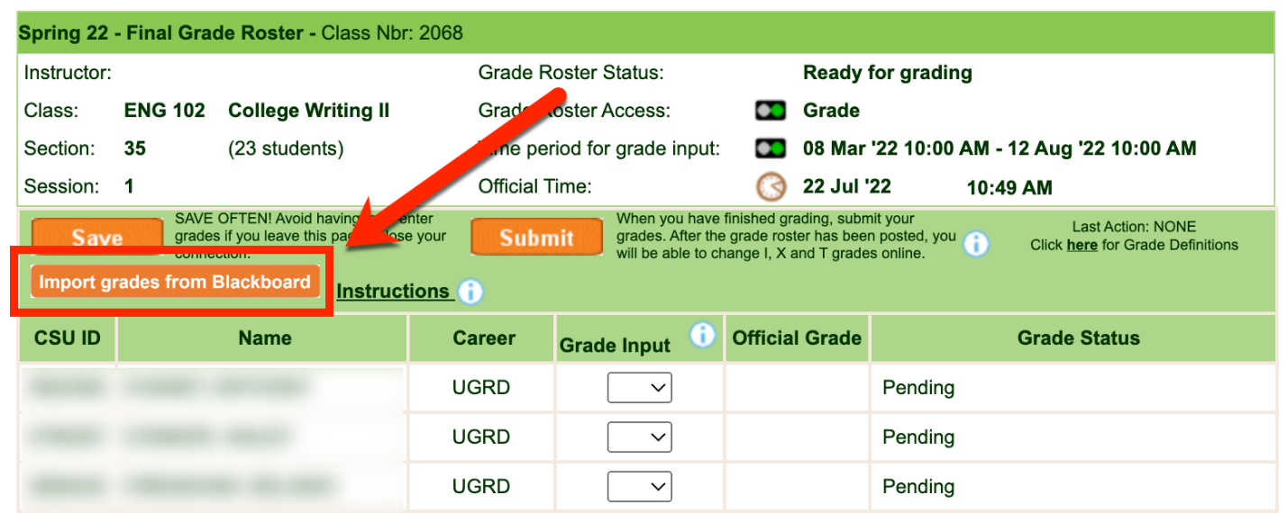

- You will see the following prompt before grades are imported. This message is to inform you that any grade information that has been already entered will be overlaid. Click OK.

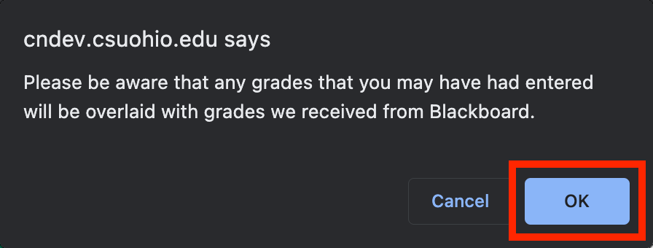

- You will see another message stating how many grades were imported successfully. Click OK.

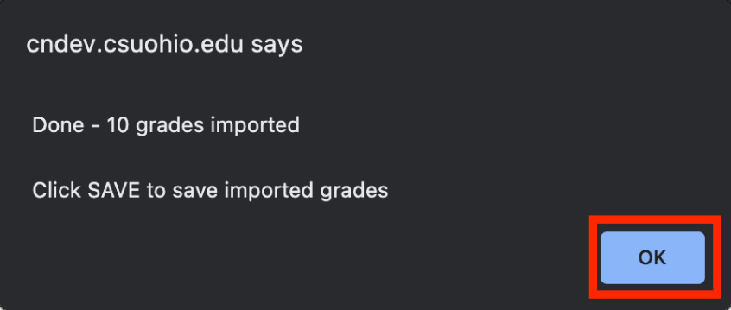

- You will now see the imported grades under the Grade Input column.

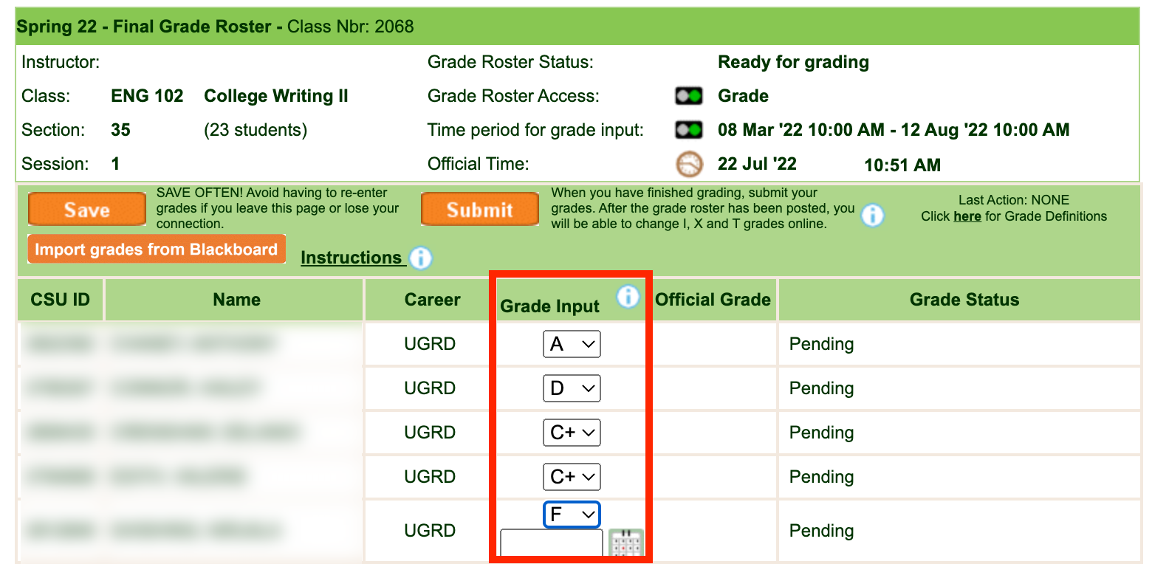

- Click the orange Save button.

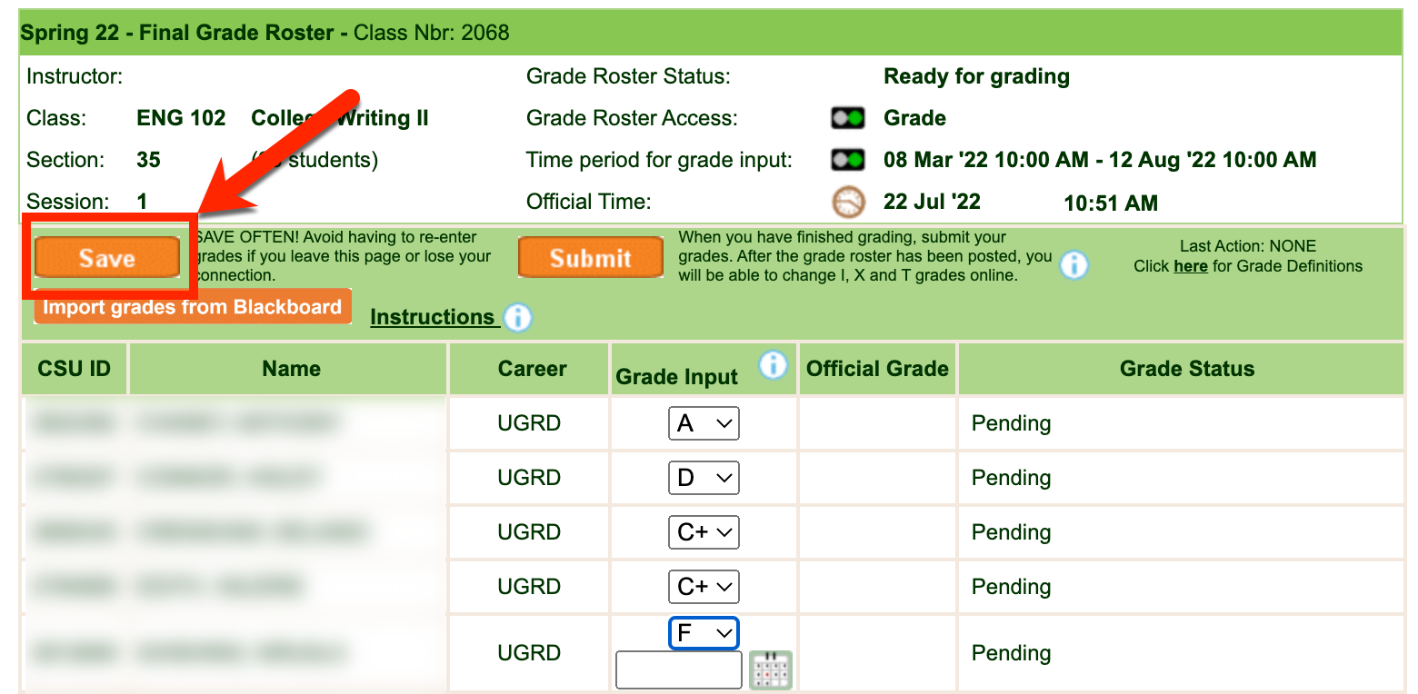

- Once all the grades have been imported and thoroughly reviewed for accuracy you are ready to Submit the grades. Once you Submit, importing grade from Blackboard is no longer available. Click the orange Submit to finalize grading for this course.

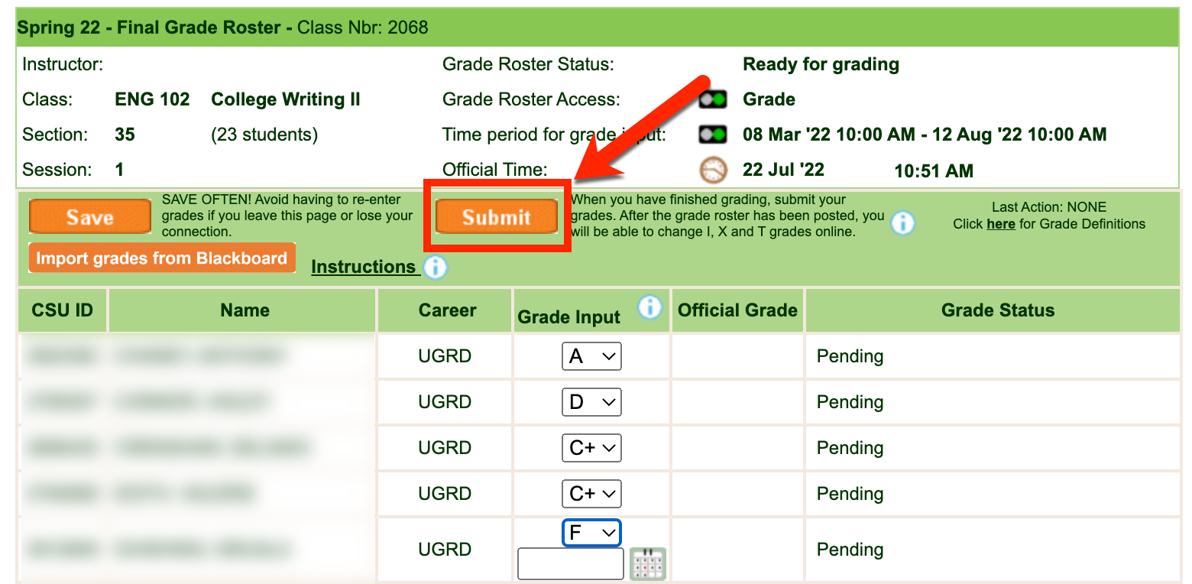

Possible Errors

- If you are not seeing grades in CampusNet that were sent from Blackboard, please confirm that you have selected the correct column in Full Grade Center to be your External Grade column.
- If the correct column has been selected as the External Grade, please confirm that you have set the Primary Display of that column to be a Letter.
  - If you do not set the Primary Display as a Letter and attempt to send a numerical value, CampusNet will warn you that the value is not allowed and will not import them until the Primary Display for that column has been adjusted in Blackboard.

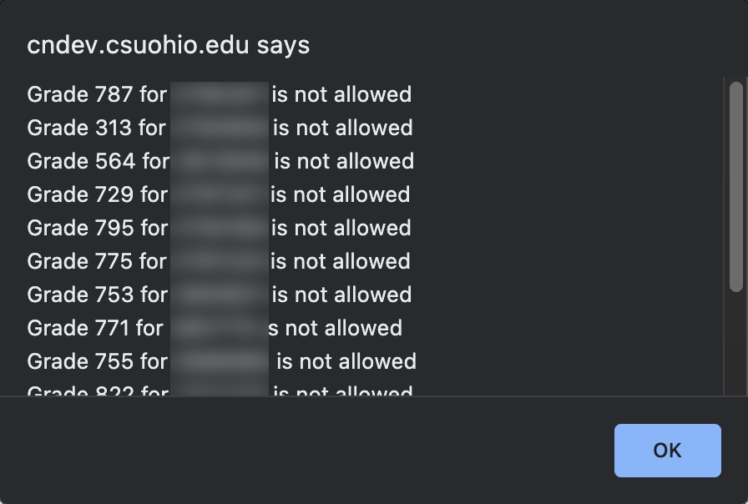

- If you are teaching a graduate level (or combined undergraduate and graduate) course and did not adjust the Grading Schema to remove the C+ row, CampusNet will provide an error for any graduate student who receives a C+ and just that grade will not import. All other grades will successfully import.

