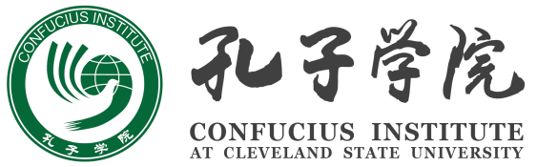

Confucius Institute at Cleveland State University
Ohio Association of Teachers of Chinese

The 2nd Ohio K-12 Chinese Speech Contest Application Form
(Registration ends on April 24, 2014)

Applicant Information

Last Name______________________ First Name__________________________________
Gender Male ______________ Female _____________________
Birthplace : | Country of Citizenship :
Home Address:

Email Address: | Home Phone:
First Language:

Father’s first language: | Mother’s first language:
I have studied Chinese for a total of ________ years since ___________ year old. This includes:

Elementary school ___________ years; Middle School _________________years;

High School _______________ years.
Immersion experience:
I have spent _______days, or ______ months, or ________ years in Mainland of China, Taiwan, Hong Kong or other places where Mandarin is the official language.
Would you like to give a performance at the end of the contest? This is entirely optional.
Yes ______________ I will perform _________________________. No, thank you. ______________
Signature of Applicant Date

Signature of Parent or Guardians Date

Confucius Institute at Cleveland State University
Ohio Association of Teachers of Chinese

The 2nd Ohio K-12 Chinese Speech Contest Application Form
(Registration ends on April 24, 2014)

School and Chinese Teacher Information

School Name: |  | School Phone:
School Address:

Chinese Teacher’s Name:

Chinese Teacher’s Email:

Chinese Teacher’s Phone:

Chinese Teacher’s Signature:

If you have any questions, please send e-mail to w.liu17@csuohio.edu or wpwnsyx@gmail.com.

