1 | Login to the PeopleAdmin system.  To locate the system, go to the CSU Home Page (www.csuohio.edu) and  Click on MYCSU | 
2 | Click on Human Resources Position Description, Performance Evaluation and Vacancy Management System | 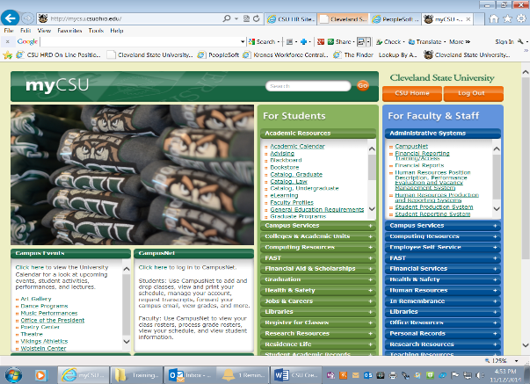
3 | Login using your CSU ID number and your CampusNet password | 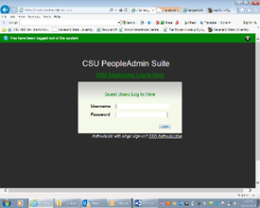  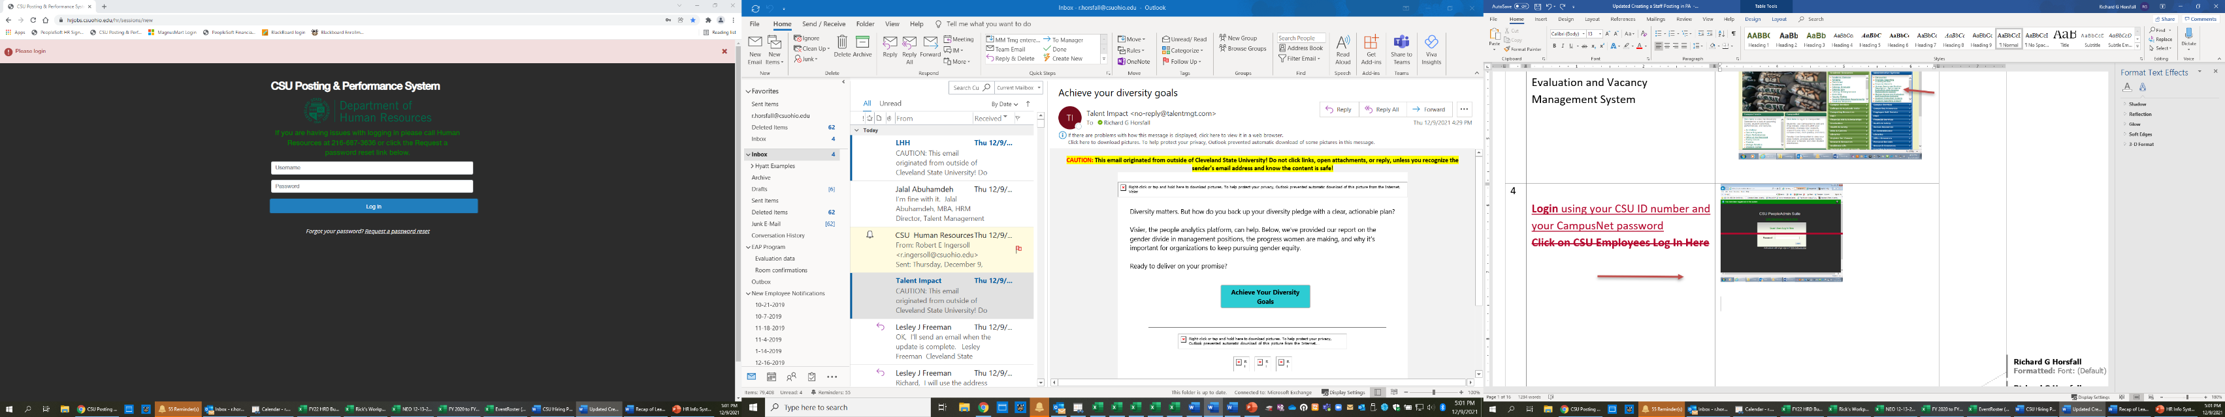
4 | Click the User Group drop down box  Select “Hiring Manager” | 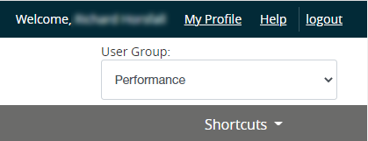
5 | The software defaults to Applicant Tracking System upon opening. Look for this in the upper left corner of the screen. | 
6 | If you need to change it, click on the three blue dots and select “Applicant Tracking System” from the drop down menu. | 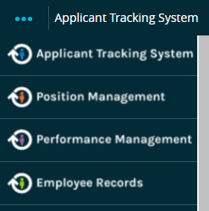
7 | Hover/Click over the “Postings” tab on the top  Select “Staff” | 
8 | Click on the “Create New Posting” button located on the upper right of the screen | 
9 | Click on the link to “Create from a Position Description” | 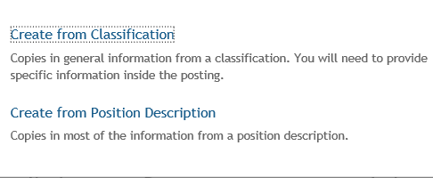
10 | Type the position name or current incumbent name into the search box  Click Search
11 | The search will return a list of positions | 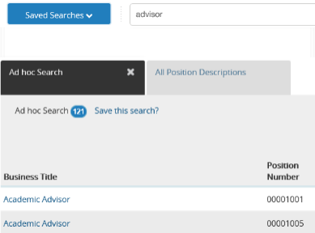
12 | Select the position desired for creating the posting.  Click on the Business Title or name of classification | 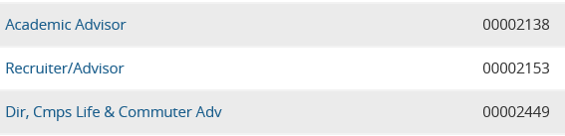
13 | Click on the “Create Posting from this Position Description” link from the menu on the top right. | 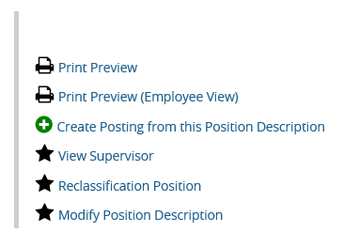
14 | Review/update the Business Title, if necessary  * Required Field
15 | Review/update Organizational Unit information as needed (Use drop down fields)  VP / Provost Level  College / Division  Department | 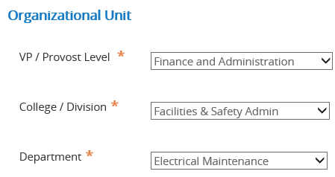
16 | Select the “Staff” option from the list under Job Alert | 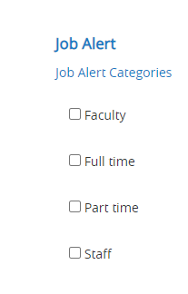
17 | Check the “Short Application” for Accepted Application Forms  (The short form is usually used for Staff postings) | 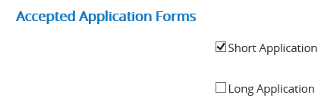
18 | Click the box at the bottom right to “Create New Posting” | 

Once the main posting shell has been created, additional information must be entered regarding the position details.

Work with your HR Liaison/Budget Manager to ensure all required fields are complete and accurate. Requisitions with inaccurate information will be sent back and will delay the posting process.

NOTE: As you work your way through the information, enter or select information only in the fields requested below. Please note that you will skip some sections entirely.
Posting Details section
19 | Review the Business Title. Update if needed
20 | Add the Position Number. If new, Enter 0000TBD. The new PN will be added later by the Budget Office. | 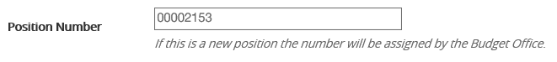
21 | Add Supervisor’s name and position # | 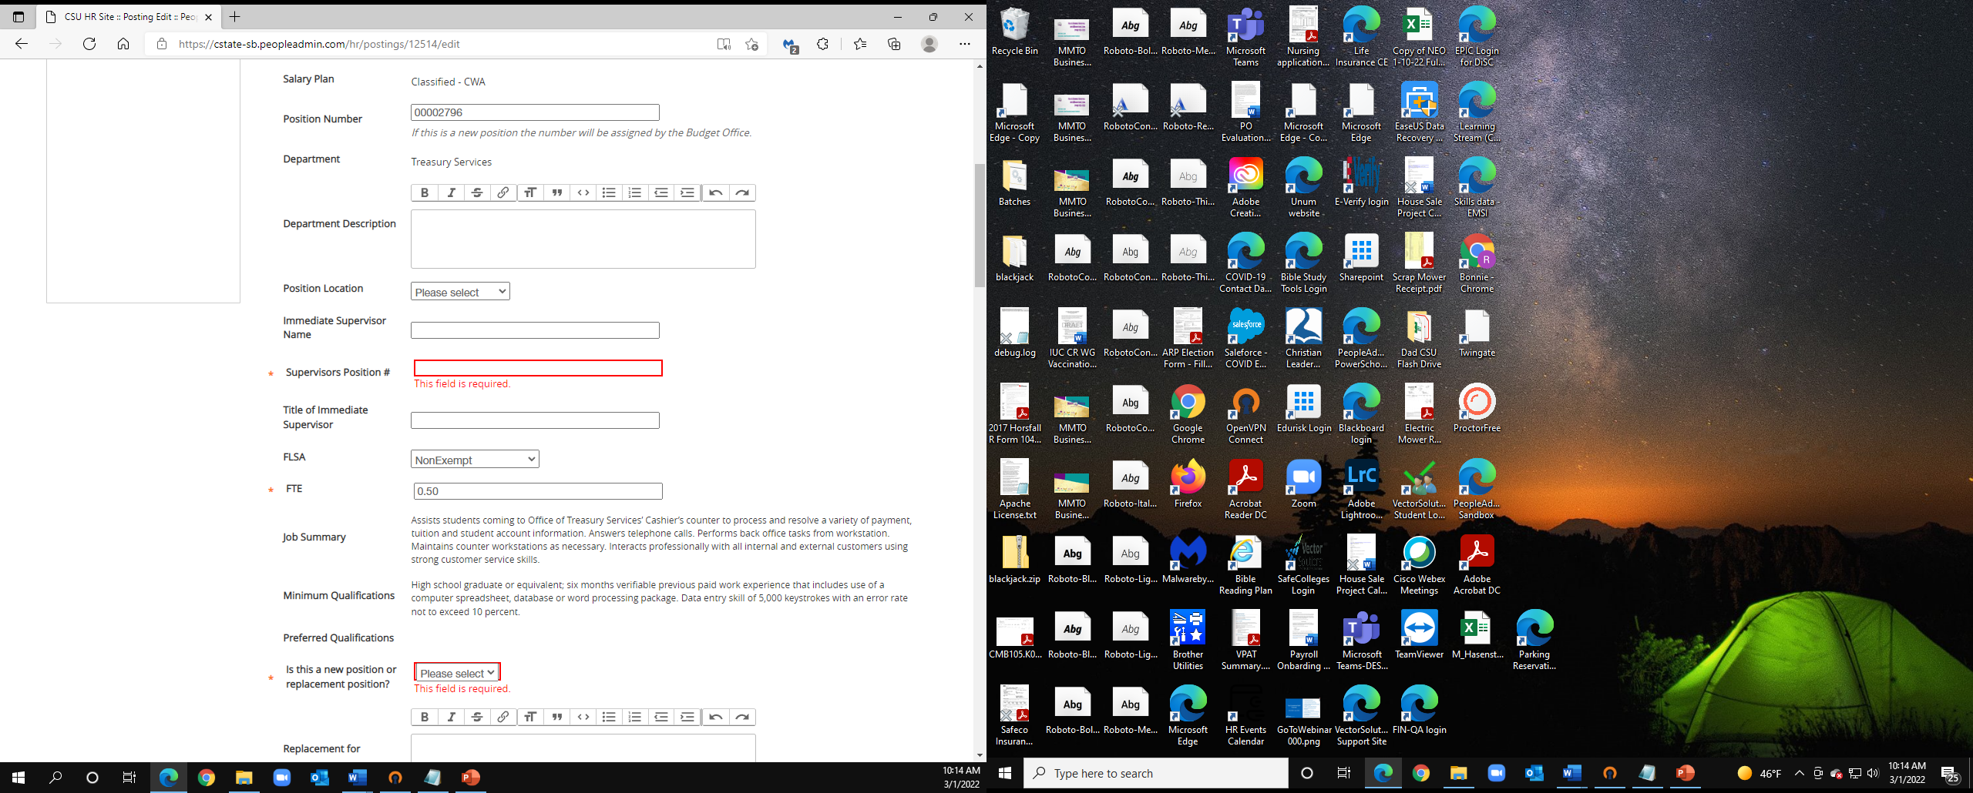
22 | Add the Full Time Equivalent (FTE) for the position  (1 = Full Time, .75 = 30 hrs/wk, etc.)
23 | Select New or Replacement position | 
24 | Select Funding: Regular, Temporary or Funds Available

25 | Add date expires if you selected anything other than Regular for position type. No date required for Regular.  Note: Date must correspond to date indicated on the employment contract or waiver, if applicable. | 
26 | Add Background Check Account number  (List account number to charge fees for background check) | 
27 | Select Full Time/Part Time
28 | Scroll to bottom of page and select “Save & Continue” | 
Position Rationale section
29 | Enter the rationale for backfilling or creating a new position | 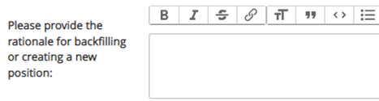
30 | Enter the impact on operations if the position is not filled | 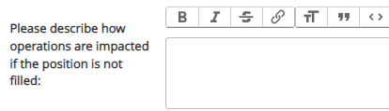
31 | Enter how the position aligns with CSU 2.0 recommendations and/or business strategy | 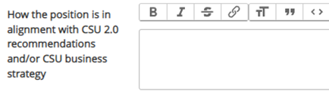
32 | List all alternatives and why they were deemed not feasible.  When finished, select Save & Continue | 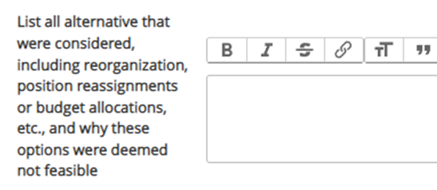
Position Budget Information section
33 | Click the “Add Budget Summary Entry” button to open additional fields
34 | Enter the Combination Code(s)  (Four-digit department code & four-digit account code - e.g. xxxx-xxxx)  Note: If an additional entry box appears for Combination Code, enter the same information in it as well. | 
35 | Enter the percentage funded. If the position is funded from multiple accounts, click Add Budget Summary Entry to open additional Combo code entries. Check “Remove Entry” box if there are unused entries. | 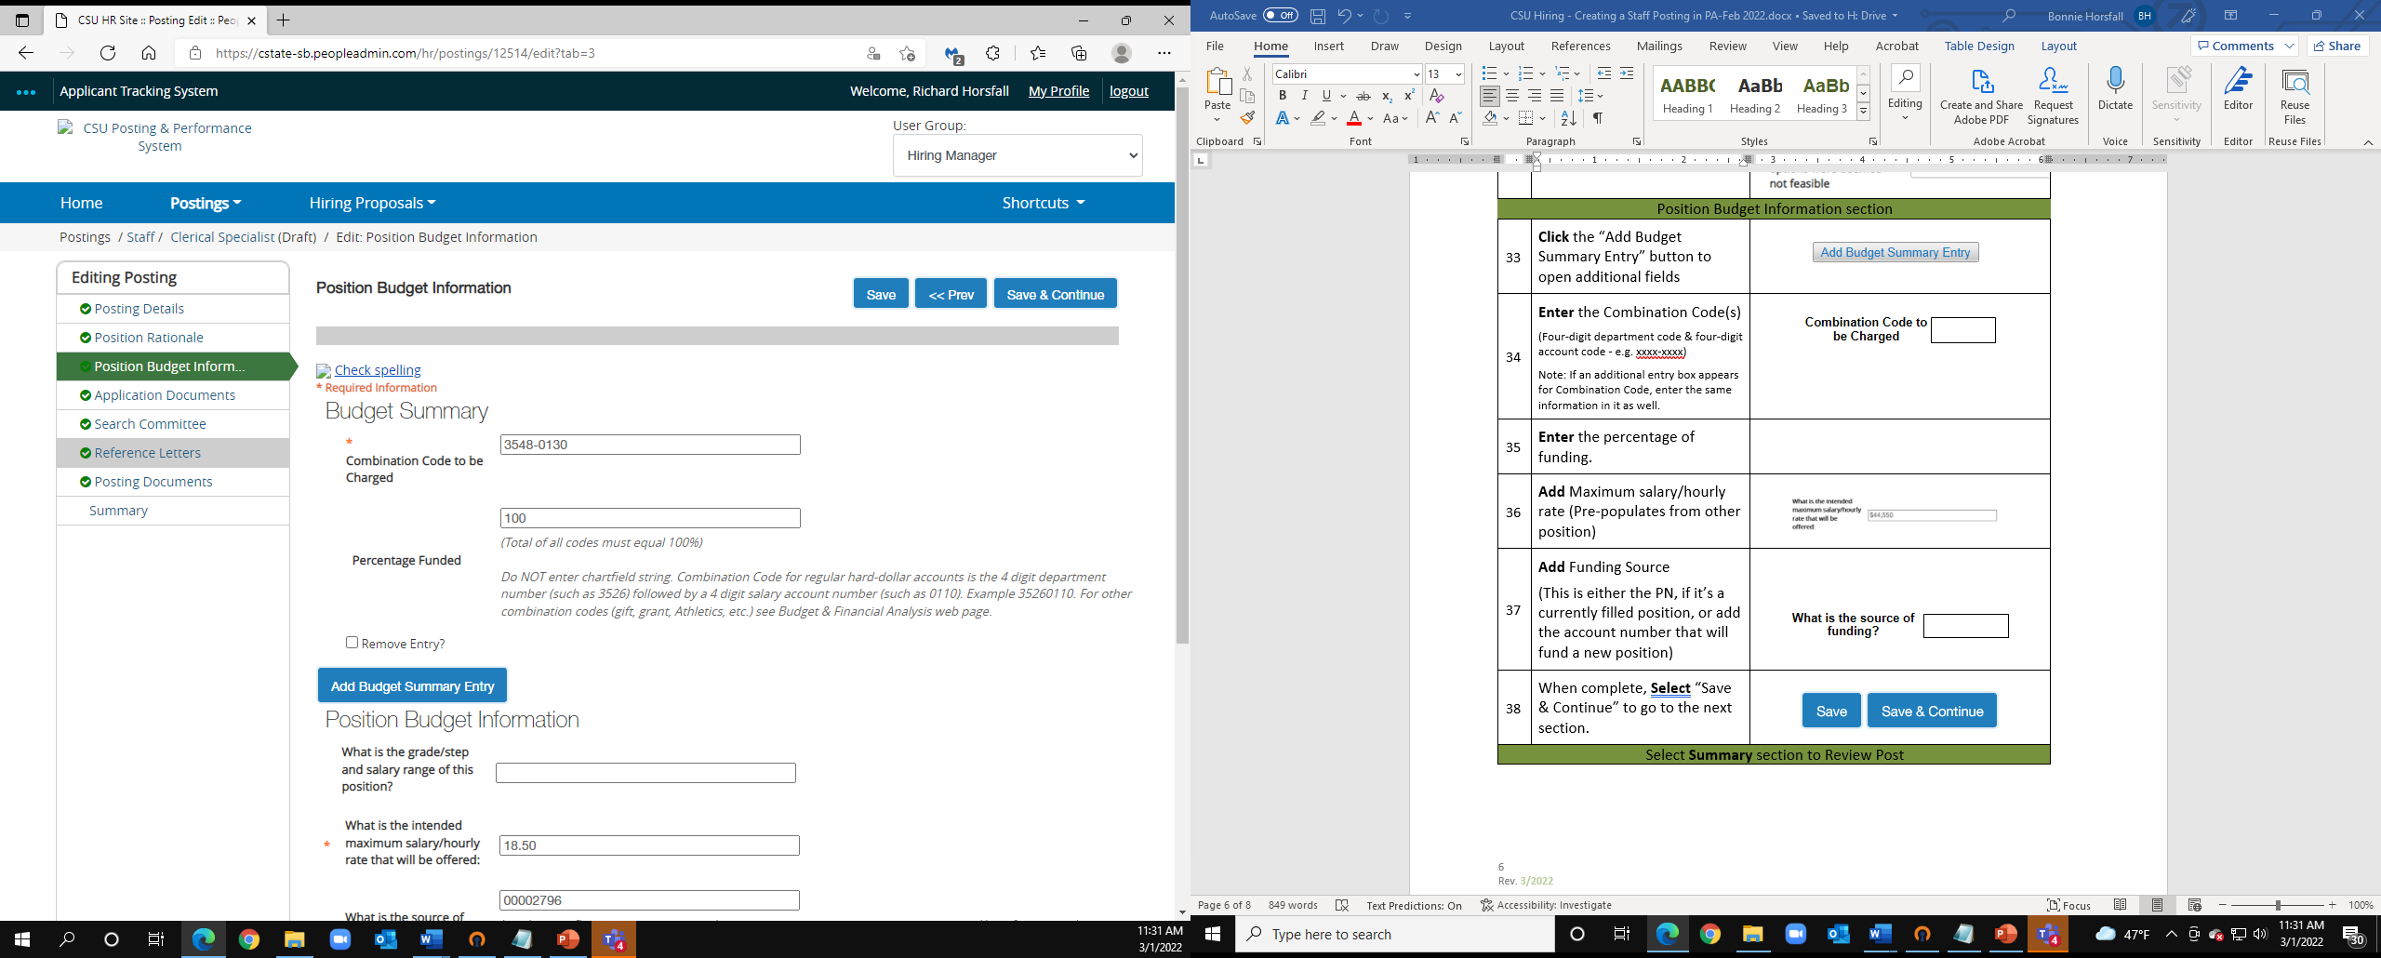  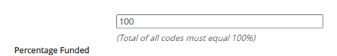
36 | Add Maximum salary/hourly rate (Pre-populates from other position) | 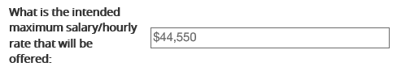
37 | Add Funding Source  (This is either the PN, if it’s a currently filled position, or add the account number that will fund a new position) | 
38 | When complete, Select “Save & Continue” to go to the next section.
Select Summary section to Review Post
39 | Review the Posting  To make any edits prior to submitting, Click the “Edit” button next to the title of the section you want to update | 
40 | When finished editing, Hover over the “Take Action On Posting” button. | 
41 | From the drop-down menu,  Select “Send to HRBP (move to HR Business Partner) | 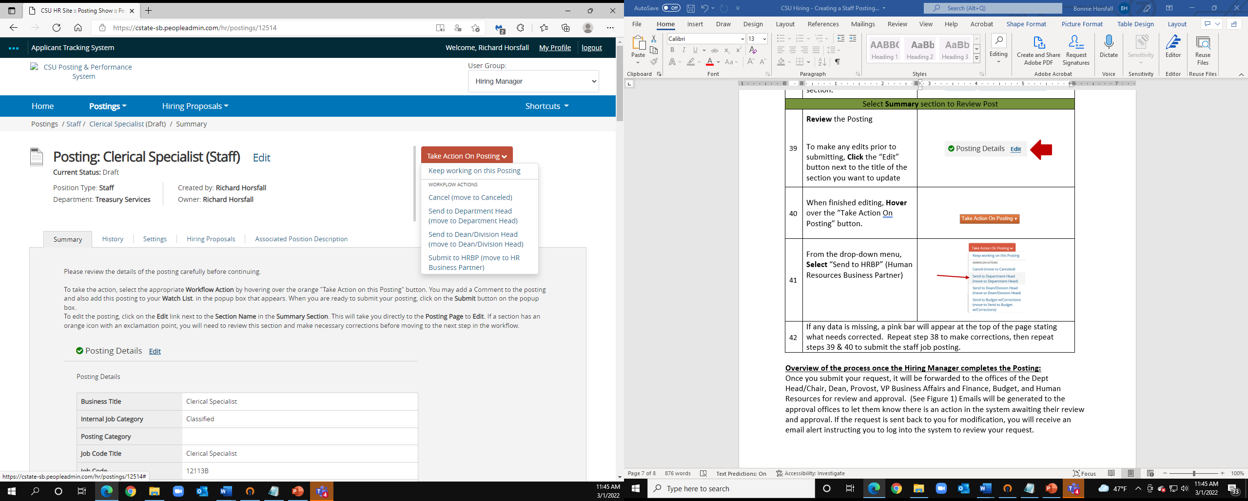
42 | If any data is missing, a pink bar will appear at the top of the page stating what needs corrected. Repeat step 38 to make corrections, then repeat steps 39 & 40 to submit the staff job posting.

Overview of the process once the Hiring Manager completes the Posting:
Once you submit your request, it will be forwarded to the offices of the Dept Head/Chair, Dean, Provost, VP Business Affairs and Finance, Budget, and Human Resources for review and approval. (See Figure 1) Emails will be generated to the approval offices to let them know there is an action in the system awaiting their review and approval. If the request is sent back to you for modification, you will receive an email alert instructing you to log into the system to review your request.

Hiring Manager | Starts
HRBP |  | Review/Approve
Dept Head |  | Review/Approve
Dean/Div Head |  |  | Review/Approve
Provost/VP |  |  |  |  |  | Review/Approve
Budget |  |  |  |  |  |  |  |  | Review/Approve
Human Resources |  |  |  |  |  |  |  |  |  |  |  |  | Post
Figure 1

