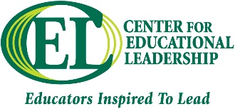
ELCC Scoring Rubric | [Semester Year]
CEL 615- Raising Student Achievement
Discussion Board Rubric

 | Levels of Achievement
Criteria | Needs Improvement | Meets Most Requirements | Meets/Exceeds Requirements
Original post in response to the question posted by the instructor | 0 Point  Participant did not fully address discussion topic question or relate it to course materials. Post length is less than a paragraph and may have contained grammatical or stylistic errors. | 15 Points  Participant may have fully addressed discussion topic question, but may not relate the topic to course materials and/or stimulate further discussion. | 25 Points  Participant fully addresses the discussion topic question, relates the topic to current or past course materials and stimulates further discussion.
Responses to other students | 0 Points  Participant did not post any replies to other participants or posted only short statements that did not stimulate the discussion. | 15 Points  Participant only posted one response to another classmate and/or did not post response(s) that stimulated further discussion. | 25 Points  Participant posted two responses to classmates and responses stimulated further discussion as well as described what the participant liked or disliked about the post and why.

