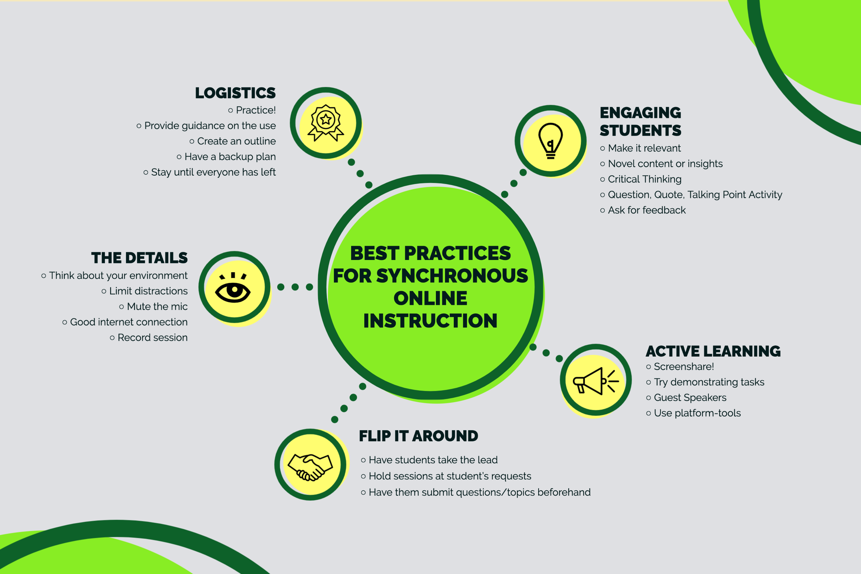

Best Practices for Synchronous Online Learning

What is Synchronous Online Learning? It is similar to being in-person, except online. Synchronous Online Learning is where students are engaged in learning at the same time. One of the most common forms is through video conferencing. It’s a great way for students to feel connected to other students and you!

What Can You Do to Make Synchronous Class Better? There are many different methods to improve your synchronous sessions. You can start with the finer details such as getting comfortable with the software and creating engaging activities. Eventually, you can have students become the facilitators of the session!

Five Areas to Improve Your Synchronous Class – Below are five areas to focus on to improve your synchronous class and questions to ask yourself.

The Details – these are the small distractions you might not think about but can distract from learning.
- Think about your environment. Think about what you will look like on screen. Is there adequate lighting? What is in the background? How will you dress? This can convey how serious you are about your class.
- Limit distractions to you and students. This goes along with the environment. Noises such as pets, machines, or fans can cause you to be distracted or make it hard for students to hear. Also, while you might have a unique bookshelf you want to use as your background, remember, students will be trying to figure out all of the objects on the shelf once their attention starts to drift and not pay attention to you.
- Mute the mic. Mute instructor/student mic when not speaking.
- Good internet connection. Check your bandwidth for video, screen, and audio sharing.
- Record your session. Technology issues happen. It’s a good practice to record your session to give to your students for review in case they couldn’t attend.

Logistics – You will not only need to plan a session, but you also must have the confidence in understanding the software and help with basic troubleshooting.
- Practice! Get to know the software you are using. Do you know what all the buttons do? How to share documents? How are you going to handle the chat feature while teaching? Are you going to use breakout rooms for student groups?
- Provide guidance during the session on use. Students might not know all the features of Zoom or Collaborate so be patient.
- Create an outline. Think about what topics you want to cover, materials and timing.
- Have a backup plan. Things happen so make sure you have another way of contacting students and delivering the lesson.
- Stay until everyone has left. Some students may have questions that they don’t want to ask in front of everyone so stay late to answer any follow-up questions.

Engaging Students – You want your students to pay attention to what you are teaching so make the learning process engaging to keep them focused and motivated.
- Make it relevant. Explain why students should care about this topic and how it will help them solve problems that matter to them.
- Novel content or insights. Avoid duplicating what has been already covered in cousre materials. Make sure there is a benefit to them attending.
- Critical thinking. One activity you might try is to ask questions that require students to pick a side. This way they will have to analyze the problem and provide a reason for their choice.
- QQTP. Students prepare a question, quotation and talking point for the session.
- Ask for feedback. This can help improve your content and student retention.

Active Learning – It can be easy to turn your video conferencing session into a lecture but if you want to improve student’s performance try adding some active learning techniques.
- Screenshare! Let students see what you are talking about to give them a better understanding.
- Try demonstrating tasks. Instead of talking through how to do something show them.
- Guest Speakers. Give your class a real-world view of a topic by inviting professionals or even alumni in from the field.
- Use platform-tools. The use of polls, for example, provides interaction between you and students and helps you gage how well students are following along.

Flip it Around – You don’t always have to be directing the instruction. An option is to have students guide the conversation through curiosity or as a means of assessment.
- Have students take the lead. Have students create presentations and demonstrations instead of creating everything yourself. This will allow them to develop long-distance communication and collaboration skills.
- Hold sessions at student’s requests. Invite students to request lectures on specific topics, current events, or review for a big test. These sessions will be more targeted towards student interest and have a likely chance of holding their interest.
- Have students submit questions/topics beforehand. Send a quick email asking students for questions, experiences or opinions about the upcoming session. This will help you prepare materials and incorporate students’ interests.

The following are best practice for Blackboard Collaborate and Zoom in addition to what is above:

Blackboard Collaborate Best Practices
- Close any extra programs that you don’t plan to share through Blackboard Collaborate so all resources can go to Collaborate and applications you will share.
- Keep your internet browser up to date. If something is not working in one browser try another.
- Limit video camera if experiencing connection issues.
- Turn your presentations into PDFs and upload to Collaborate before the session.
- Give attendees a few minutes to join.
- Keep the attendee panel open to see who is there and has their microphone on/off.

Zoom Best Practices
- Secure you Zoom meetings to prevent an unwanted guest.
- Try out the waiting room feature to let students know they are in the right spot and prevent unwanted visitors.
- Review your host controls and meeting settings ahead of time.
- Manage screen sharing for participants.
- Toggle between Active Speaker and Gallery views to engage with students.

