Importing your references to Zotero
1. Click the options button (gear icon) and select Import
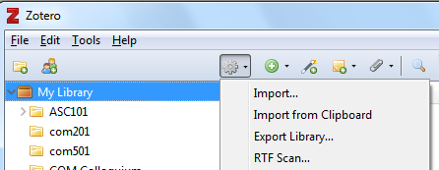
2. In the file explorer, navigate to where your Exported Refworks .txt file is saved, and select it. The references will import to a new folder with the name of the .txt file.
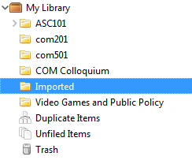
Importing your references to Mendeley
1. In Mendeley, click Create a Folder to make a new location for your imported references.
2. Click on the new folder to make that the active location
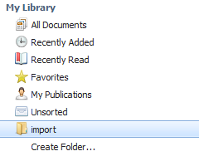
3. Click Add Files, navigate to where your Exported Refworks .txt file is saved, and select it. Your references will import in the folder.
